G | ? | ? | M | ? | ? | k | ? | ? |  | ? | c | m | ? | ? | μ | ? | ? | n | ? | ? | p
giga |  |  | mega |  |  | kilo |  |  | base |  | centi | milli |  |  | micro |  |  | nano |  |  | pico
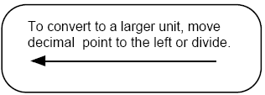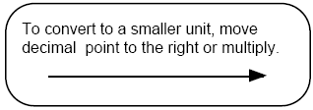

G | ? | ? | M | ? | ? | k | ? | ? |  | ? | c | m | ? | ? | μ | ? | ? | n | ? | ? | p
giga |  |  | mega |  |  | kilo |  |  | base |  | centi | milli |  |  | micro |  |  | nano |  |  | pico

G | ? | ? | M | ? | ? | k | ? | ? |  | ? | c | m | ? | ? | μ | ? | ? | n | ? | ? | p
giga |  |  | mega |  |  | kilo |  |  | base |  | centi | milli |  |  | micro |  |  | nano |  |  | pico

G | ? | ? | M | ? | ? | k | ? | ? |  | ? | c | m | ? | ? | μ | ? | ? | n | ? | ? | p
giga |  |  | mega |  |  | kilo |  |  | base |  | centi | milli |  |  | micro |  |  | nano |  |  | pico

