How to estimate when measuring  EHS Cλ3MIs+rγ  Mr. Genest | 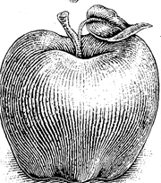 | Name_________________  Date__________________  visit http:genest.weebly.com
Announcements:
- Our first big test is Thursday, September 24, 2015
- Memorize twenty elements total by Friday September 18, 2015

- Calculate the volume of a block that is 0.00371cm x 0.044cm x 0.68cm

- What is the perimeter of a rectangle that is 2.008cm x 5.4cm?**

