How to think about two related measurements | 1. Write a hypothesis of the form  “I believe the amount of * depends on the amount of **  ________________________  ________________________  ________________________  ________________________  ________________________  ________________________  ________________________  ________________________ |  | 3. Graph  Add a best fit line to this data.  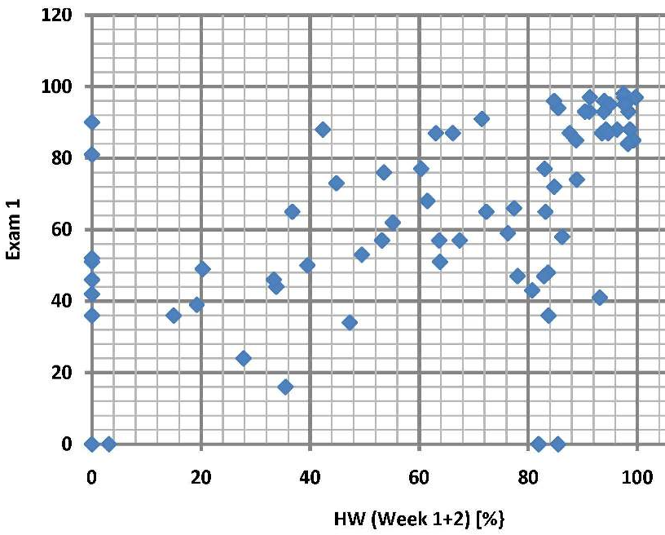
 | 4. Slope The slope can NOT be based on data points.  It must be based on the best-fit line you drew with the ruler.  Use the formula $\frac{∆y}{∆x}= \frac{y2-y1}{x2-x1}$ for any two points on the line.  Please show units. |  |  |  | 5. Sentence  Based on the slope you calculated in Step 4, write a sentence similar to “For every 2 bags there are 34 potatoes”. Your X variable always goes first in such a sentence.
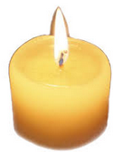
Your Period_____Name ____________
Either use your 6 rules from the textbook OR use today’s Atlantic-Pacific rules. Both work. For each number below, determine how many significant figures it has.  1) 3.0800 sec ______  2) 0.00418 m ______  3) thirty dirty birds ______  4) 91,600 people ______  5) 0.003005 meters ______  6) 1 pound of bird feces ______  7) 250 kg ______  8) 780,000,000 m ______  9) 0.0101 sec ______  10) 0.00800 g ______  11) 0.0078 cm ______  12)1.090 grams ______  13) 78900 grams ______  14) 25 cents in a quarter ____  15) 2200000 meters ______ | Multiplying/Dividing with Measurements  The product or division will never have any more precision then the measurement with the least number of significant figures.  For each problem determine the significant figures (SF) of each number and then circle the lowest number of SF. Round the answer to that many SF.  Model:  32.90 grams / 25.2 ml = 1.3055556 = 1.31 grams / ml  4  3  1. 12.8 x 5.2 =  2. 100 x 8.57 =  3. 6008 / 8.724 =  4. 72 / 7 =  5. 600 / 38 =  6. 0.00005 x 538 =

