Review #1  EHS Cλ3MIs+rγ  Mr. Genest |  | Name_________________  Date__________________  Tutors! Adults! Help this young chemist by visiting http:genest.weebly.com with any smart phone

- Our first big test is this Thursday, September 24, 2015
- For a complete review, go re-do old homework and notes from Sept 2 to Sept 21.

- Write the measurement for each letter. Always make the last digit zero when the hairline hits the mark dead center.
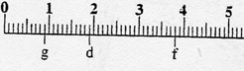 G ______ D________ F________

 | - Answer questions  for these lines. Line A  has been done below for you  as an example. |  | 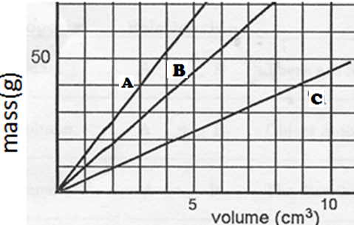
For Line A  - Calculate the slope  of Line A  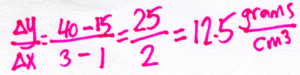  - Write a “For every…” sentence.  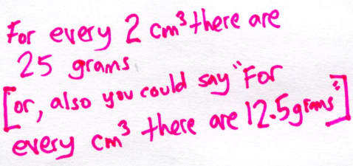 |  | - For Line B  - Calculate the slope of Line B  - Write a “For every…” sentence. |  | - For Line C  - Calculate the slope of Line B  - Write a “For every…” sentence.

- What is the answer, to the correct number of significant figures of each

  - 83 x 0.7 =
  - 83 + 0.7 =

- The Law of Conservation of Mass says that ___________________________________________

IMPORTANT In problems #7 - #9, pay special attentionto have the number of particles in the microscopic before and after explain the weight change that is described in each case.

- Bending a straight wire into a 90° angle [Your drawing should explain why the total mass stays the same.] |  | macroscopic view |  |  | microscopic view
 |  | before | after |  | before | after
Symbols that I used:

- a cotton ball on the ground, before and after a rain storm [Your drawing should explain why the total mass increases.] |  | macroscopic view |  |  | microscopic view
 |  | before | after |  | before | after
Symbols that I used:

- before: a wet cotton ball on the ground, after: same cotton ball after six hours in the sun [Your drawing should explain why the total mass decreases.] |  | macroscopic view |  |  | microscopic view
 |  | before | after |  | before | after
Symbols that I used:

- Write the measurement for each letter. Estimate between marks when the hairline doesn’t hit dead center. If it does, make the last digit zero.
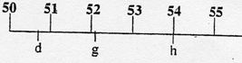 D ______ G________ H________
- Write the measurement for only g, h, & f in these blanks
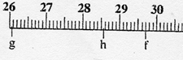 G ______ H________ F________

