Review #2  EHS Cλ3MIs+rγ  Mr. Genest |  | Name_________________  Date__________________  Tutors! Adults! Help this young chemist by visiting http:genest.weebly.com with any smart phone

There IS a way to know what's on the test.Have you noticed that the quizzes have large chunks of material taken directly from the worksheets you just finished?

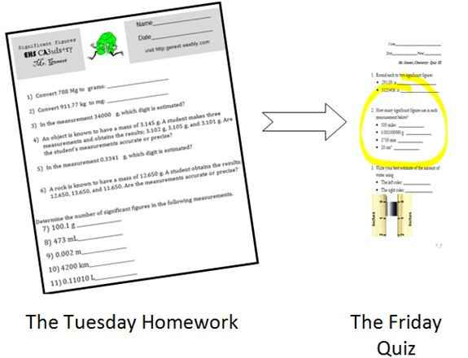

- Our first big test is this Thursday, September 24, 2015
- This review sheet does not contain every word and skill we learned. It can’t. For a complete review, go re-do old homework and notes from Sept 2 to Sept 21.

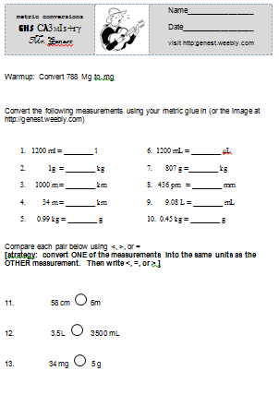 | 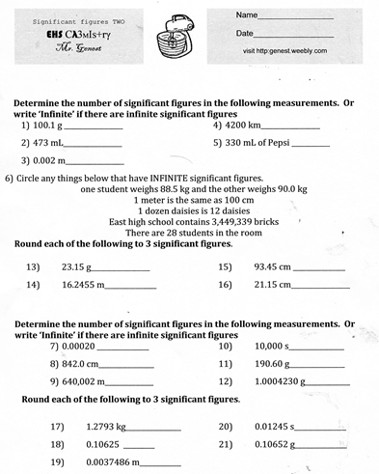

 | Answer questions  for these lines. |  | 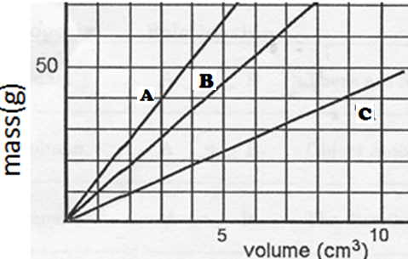
- For Line A  - Calculate the slope  of Line A  - Write a “For every…” sentence. |  | - For Line B  - Calculate the slope of Line B  - Write a “For every…” sentence. |  | - For Line C  - Calculate the slope of Line B  - Write a “For every…” sentence.

- When we pulled the steel wool apart, you found that the mass was unchanged. But, when you heated the steel wool, you found that the mass increased. Explain.

- Draw diagrams (at the simple particle level) of the steel wool before and after the change.
Steel wool pulled apart

- When the sugar dissolved in the water, you found that the mass remained unchanged. When the Alka-Seltzer dissolved in the water, the mass of the system changed. Explain.

Draw diagrams (at the simple particle level) of each of the materials before and after it was dissolved.

