|  |  |  |
| --- | --- | --- |
| Review for Wednesday’s Test  EHS Cλ3MIs+rγ  http:genest.weebly.com | https://encrypted-tbn3.gstatic.com/images?q=tbn:ANd9GcQgrZpcwJhkjSkLbR0WWH4mISkp83xbPV22hDOBGSroEf5TL82s | Name\_\_\_\_\_\_\_\_\_\_\_\_\_\_\_\_\_  Date\_\_\_\_\_\_\_\_\_\_\_\_\_\_\_\_\_\_  This is material for Test 1 – October 1st. |

|  |  |  |  |  |  |  |  |  |  |  |  |  |  |  |  |  |  |  |  |  |  |
| --- | --- | --- | --- | --- | --- | --- | --- | --- | --- | --- | --- | --- | --- | --- | --- | --- | --- | --- | --- | --- | --- |
| Handy metric reference table! This will be printed on the test. | | | | | | | | | | | | | | | | | | | | | |
| G | ? | ? | M | ? | ? | k | ? | ? | 🖐 | ? | c | m | ? | ? | μ | ? | ? | n | ? | ? | p |
| giga |  |  | mega |  |  | kilo |  |  | base |  | centi | milli |  |  | micro |  |  | nano |  |  | pico |

1. Convert 70.1 Mg to grams: \_\_\_\_\_\_\_\_\_\_\_\_\_\_\_\_\_\_\_\_\_\_\_\_\_\_\_
2. Convert 0.0009177 L to μL: \_\_\_\_\_\_\_\_\_\_\_\_\_\_\_\_\_\_\_\_\_\_\_\_\_\_\_
3. In the measurement 302300 g, which digit is estimated? \_\_\_\_\_\_\_\_\_\_\_\_\_\_\_\_\_\_\_\_

1. What are the correct names of these two pieces of lab equipment?

|  |  |  |  |
| --- | --- | --- | --- |
| 08_sheet_equipment_blanks.png |  | 08_sheet_equipment_blanks.png | 1. item 1 is \_\_\_\_\_\_\_\_\_\_\_\_\_\_\_\_\_\_\_\_\_\_ 2. item 2 is \_\_\_\_\_\_\_\_\_\_\_\_\_\_\_\_\_\_\_\_\_\_ |
| 1 |  | 2 |

**Use the syllabus for these questions. If a statement is correct, simply write *CORRECT* in the blank. If false, write a word or phrase to replace the word in the underlined portion to make the statement true. Two of the questions shown below will be on the test. *No other material from the syllabus* will be on the test.**

1. The biggest percentage of your grade in chemistry comes from tests.

\_\_\_\_\_\_\_\_\_\_\_\_\_\_\_\_\_\_\_\_\_\_\_\_\_\_\_\_\_\_\_\_\_\_\_\_\_\_\_\_\_\_\_\_\_\_\_\_\_\_\_\_\_\_\_\_\_\_\_\_\_\_\_\_\_

1. Chemists study just two things: matter and how it changes.

\_\_\_\_\_\_\_\_\_\_\_\_\_\_\_\_\_\_\_\_\_\_\_\_\_\_\_\_\_\_\_\_\_\_\_\_\_\_\_\_\_\_\_\_\_\_\_\_\_\_\_\_\_\_\_\_\_\_\_\_\_\_\_\_\_

1. The final exam in June does not cover material from first semester.

\_\_\_\_\_\_\_\_\_\_\_\_\_\_\_\_\_\_\_\_\_\_\_\_\_\_\_\_\_\_\_\_\_\_\_\_\_\_\_\_\_\_\_\_\_\_\_\_\_\_\_\_\_\_\_\_\_\_\_\_\_\_\_\_\_

1. If absent you must make up a missed lab day.

\_\_\_\_\_\_\_\_\_\_\_\_\_\_\_\_\_\_\_\_\_\_\_\_\_\_\_\_\_\_\_\_\_\_\_\_\_\_\_\_\_\_\_\_\_\_\_\_\_\_\_\_\_\_\_\_\_\_\_\_\_\_\_\_\_

1. If absent you must make up a missed test.

\_\_\_\_\_\_\_\_\_\_\_\_\_\_\_\_\_\_\_\_\_\_\_\_\_\_\_\_\_\_\_\_\_\_\_\_\_\_\_\_\_\_\_\_\_\_\_\_\_\_\_\_\_\_\_\_\_\_\_\_\_\_\_\_\_

1. If absent you must make up a missed quiz.

\_\_\_\_\_\_\_\_\_\_\_\_\_\_\_\_\_\_\_\_\_\_\_\_\_\_\_\_\_\_\_\_\_\_\_\_\_\_\_\_\_\_\_\_\_\_\_\_\_\_\_\_\_\_\_\_\_\_\_\_\_\_\_\_\_

1. Mr Genest is here to give help every day after school.

\_\_\_\_\_\_\_\_\_\_\_\_\_\_\_\_\_\_\_\_\_\_\_\_\_\_\_\_\_\_\_\_\_\_\_\_\_\_\_\_\_\_\_\_\_\_\_\_\_\_\_\_\_\_\_\_\_\_\_\_\_\_\_\_\_

1. Mr. Genest is here for help two days a week at lunch.

\_\_\_\_\_\_\_\_\_\_\_\_\_\_\_\_\_\_\_\_\_\_\_\_\_\_\_\_\_\_\_\_\_\_\_\_\_\_\_\_\_\_\_\_\_\_\_\_\_\_\_\_\_\_\_\_\_\_\_\_\_\_\_\_\_

1. What is the density of water in g/mL? Write a “For every…” sentence for this fact:

|  |
| --- |
| 1. Estimate the level of liquid in the four containers. Remember: read between the lines and add only ONE MORE digit     \_\_\_\_\_\_\_\_\_\_\_\_\_ \_\_\_\_\_\_\_\_\_\_\_\_\_ \_\_\_\_\_\_\_\_\_\_\_\_\_ \_\_\_\_\_\_\_\_\_\_\_\_\_ |

1. What equipment have you used in our room to measure mass? \_\_\_\_\_\_\_\_\_\_\_\_\_\_\_\_\_\_\_\_\_\_\_\_\_\_\_\_\_\_
2. What equipment have you used in our room to measure volume? \_\_\_\_\_\_\_\_\_\_\_\_\_\_\_\_\_\_\_\_\_\_\_\_\_\_\_\_\_\_\_\_\_
3. If the box at left contains atoms of iron in steel wool, represent the atomic structure of the steel wool **after** strong heating in the box at right. Remember, steel wool seemed to gain weight after it was heated.



1. What was the change of mass in each experiment we did?

|  |  |
| --- | --- |
| Experiment | Was the change of mass ( - / 0 / + ) ? |
| Alka Seltzer fizzing |  |
| White precipitate forming |  |
| Iron burning |  |
| Sugar dissolving |  |

1. Use words or a picture to explain the result for the alka seltzer fizzing:
2. The 8th period chemistry class produced the following graph when they plotted 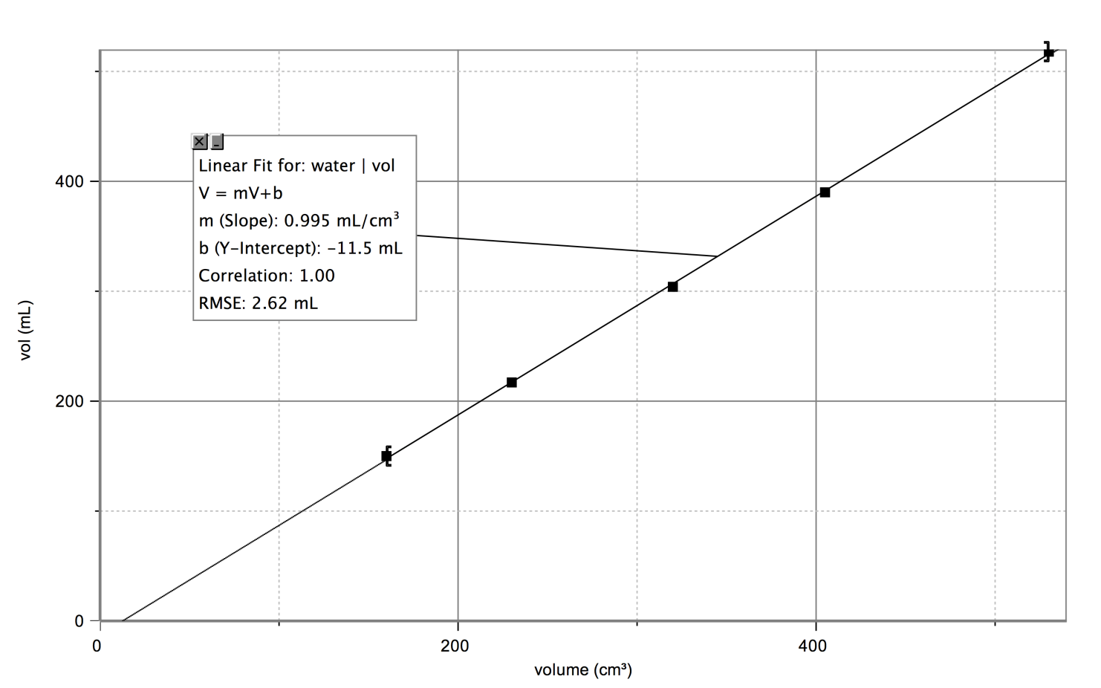the volume of water in mL vs. the volume of the container measured in cm3.

What does the slope of the above graph tell you?

1. Block A and Block B have the same mass.

A is 5 grams

B is 5 grams

Object A has a lower volume than Object B.

Object A is ( less / more ) dense than Object B.

Object C and Object D have the same volume.

D is 14 grams

C is 15 grams

Object C has a higher mass than Object D.

Object C is ( less / more ) dense than Object D.

Object E and Object F have the same density.

Object E has a lower mass than Object F.

Object E has a volume that is ( lower / higher ) than the volume of Object F.

E

???

F

???

1. The 9th Hr chemistry class produced the following graph when they were 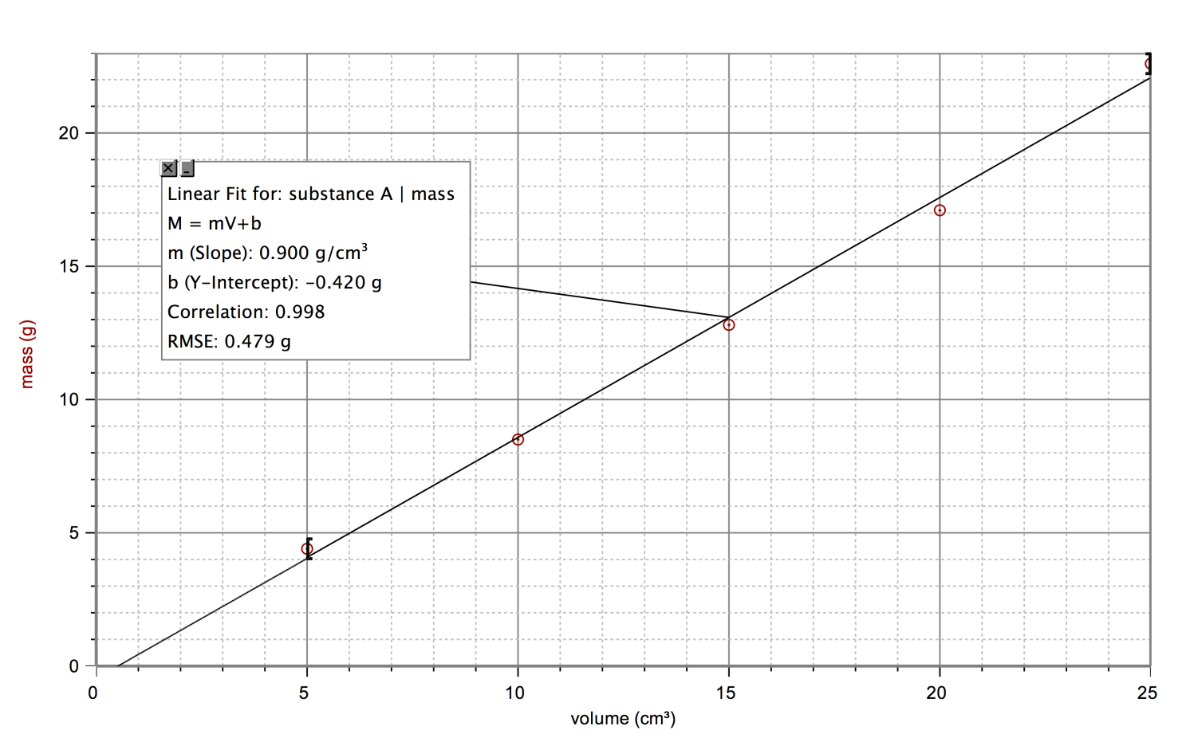measuring the mass and volume of a set of objects in the lab.

a. Calculate the slope.

b. What information is given by the slope of the graph?

c. If you put one of the objects from this experiment into water would it sink or float? Why?

d. Write a "For every..." sentence for this substance.

e. Use the information in your For Every sentence to mathematically calculate what the mass would be of a 450 mL piece of this substance.

f. Draw a line in the graph above to show what the volume would be of a 12 milliliter sample of this substance. *Do not use mathematical calculation to solve this question.*