Lab Equipment Names  EHS Cλ3MIs+rγ  Mr. Genest | 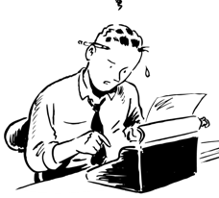 | Name_________________  Date__________________  visit http:genest.weebly.com

Using the word bank from the bottom of the page, label each piece of lab equipment below. Be able to match these names to these pictures on a quiz or test.
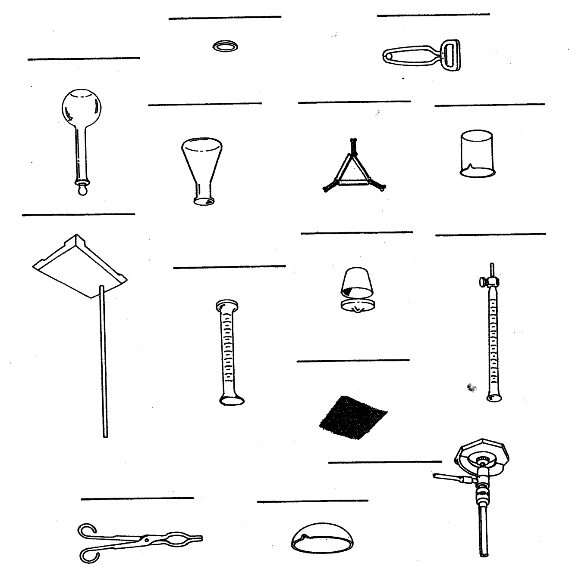
word bank
volumetric flask, Erlenmeyer flask, burette, graduated cylinder, beaker, evaporating dish, tongs, test tube holder, watch glass, crucible, Bunsen burner, ring stand, clay triangle, wire mesh screen

Convert the following measurements using your metric glue in (or the image at http://genest.weebly.com)

5. 1200 mL = ________ kL

6. 5.7 g =________ kg

7. 60.3 pm = ____________ mm

8. 9.08 cL = ________ mL

- 1200 ML = ________ kL

- 16mg = ________ kg

- 500 m = ________ km

- 3400 m = ________ km

9. Students frequently confuse the following two objects. Using your answers from Side 1 of this sheet, write the correct name under each object | 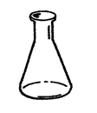  _________________ | 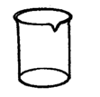  _________________

10. Students frequently confuse the following two objects. Using your answers from Side 1 of this sheet, write the correct name under each object | 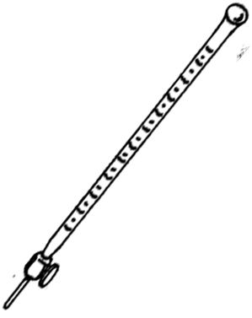  _________________ | 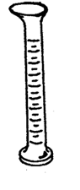  _________________

11. According to doday’s notes, what are the three most common lab injuries?

___________________________________
___________________________________
___________________________________
12. What should you throw on top of a person with burning hair?

13. What do goggles protect from?

14. What simple thing can many people do to prevent their hair from catching on fire?

