Name _ Date Period

Unit 7 Supplement to Worksheet 4

Representing Chemical Potential Energy in Reactions

For each of the reactions below, write the balanced chemical equation, including the energy term on the correct side of the equation. Then represent the energy storage and transfer using the bar graphs and sketch the chemical energy curve.

- When a small piece of sodium metal is dropped into a beaker of water, hydrogen gas and a solution of sodium hydroxide are products. The solution becomes warm.
Chemical equation including energy

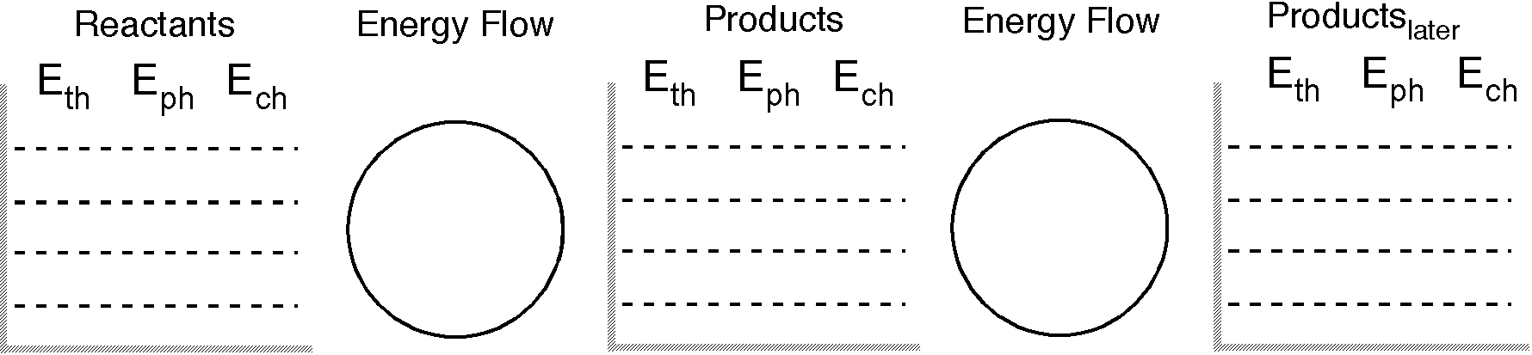 Ech curve:

Reasoning for the above diagrams:

- Heating potassium chlorate powder produces potassium chloride and oxygen gas.
Chemical equation including energy

Ech curve:

Reasoning for the above diagrams:

- Solid barium hydroxide is added to a solution of hydrochloric acid to produce aqueous barium chloride and water. The test tube feels warm.
Chemical equation including energy

Ech curve:

- When a mixture of iron filing (fine powder) and sulfur powder is strongly heated to an orange glow, solid iron(II) sulfide forms.
Chemical equation including energy

Ech curve:

- Propane gas (C3H8) burns in a barbeque grill for cooking hot dogs and burgers. Assuming complete combustion, what are the products of this reaction?
Chemical equation including energy

Ech curve:

- Upon heating, calcium carbonate decomposes into calcium oxide and carbon dioxide gas.
Chemical equation including energy

Ech curve:

- When quicklime (calcium oxide) is added to water, milk of lime (calcium hydroxide solid particles suspended in water) is formed and the mixture starts to boil.
Chemical equation including energy

Ech curve:

8. When mercury(II) oxide (red calc) is heated, a silvery liquid is formed and a gas is released. The liquid conducts electricity and the gas re-ignites a glowing wood splint into flame.
Chemical equation including energy

Ech curve:

