Introduction to Concentration Units  CλeMis+ry: http://genest.weebly.com  Stop in for help every day at lunch and Tues, Weds., &Thurs after school!  After-hours question? Email me at home: eagenest@madison.k12.wi.us | 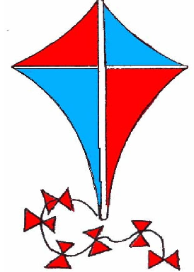 | Name_________  Period________

 | 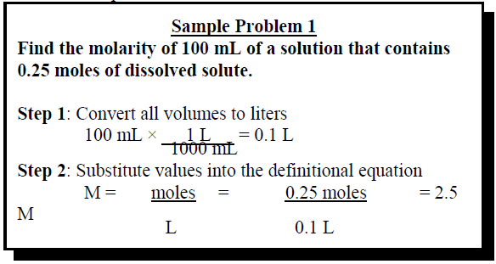 | - Find the molarity of 350.mL of a solution that contains 0.0049 moles of NaCl.

 | 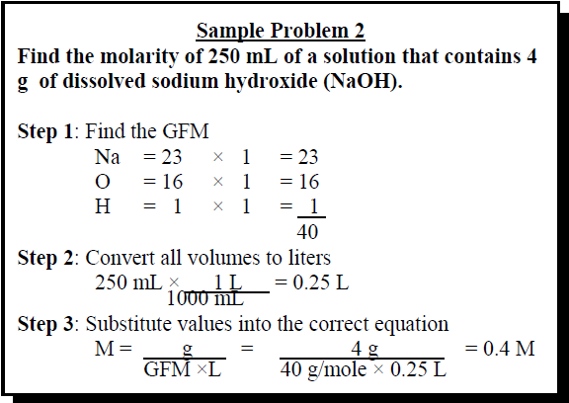 | - Find the molarity of 350.mL of a solution that contains 0.0049 grams of NaCl.

 | 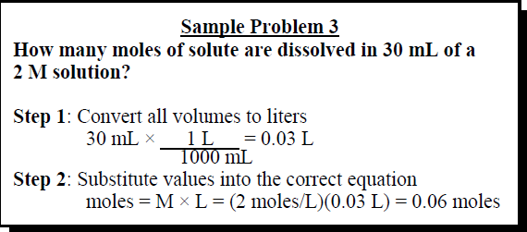 | - How many moles of CH₃Br are dissolved  in 40. mL of 2 M solution?

- 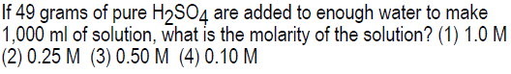

- 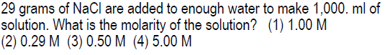

- 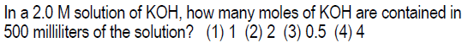

- 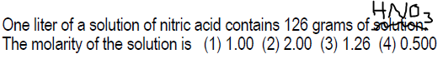

- 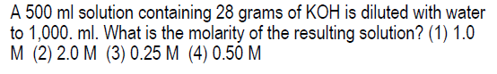

- Circle the metallic element in each.
Circle any element that is a metal | This substance is… |  | Circle any element that is a metal | This substance is…
Al(NO₃)₃ | ionic / molecular |  | N₂H₄O | ionic / molecular
- How many pieces will this fall apart into if made into an aqueous solution? (circle your choice)
(NH₄)₂CO₃ | 1? 2? 3? 4? 5? | Al(NO₃)₃ | 1? 2? 3? 4? 5?
K₂CO₃ | 1? 2? 3? 4? 5? | Li₂S | 1? 2? 3? 4? 5?

- Write your answer with a coefficient in front of each particle. For example, instead of writing Br- Br- Br- it is more common and easier to write a coefficient: 3Br-
  - Li₂S_{(s)} dissolving. Use a coeffiecient where appropriate.
________ --> ________ + ________
  - Al(NO₃)_{3 (s)} dissolving. Use a coeffiecient where appropriate.
________ --> ________ + ________

