Colligative Properties  CλeMis+ry: http://genest.weebly.com  Stop in for help every day at lunch and Tues, Weds., &Thurs after school!  After-hours question? Email me at home: eagenest@madison.k12.wi.us |  | Name_________  Period________

- Fill in the missing blanks to describe each mixture. Remember that the solvent is the thing you have the most of. |  | the solution is called: | the solute is: | the solvent is:
 |  | carbonated water (soda)
 |  |  | oxygen | nitrogen
 |  | lemonade

- Predict the particles that will form in solution |  | compound: | Gives these pieces if dissolved
 |  | AlCl_{3(aq)}
 |  | CH₃OH_{(aq)}
 |  | Ca(OH)_{2(aq)}

- When liquids are impure, their freezing points are (lower/higher) than normal.
- When liquids are impure, their boiling points are (lower/higher) than normal.
substance | boiling point [°C] | melting point [°C]
boron | 3675 | 2079
tungsten | 5660 | 3410
oxygen | -182 | -218
- If tungsten is made into an alloy by adding copper, what would be a possible boiling point for the alloy?

  - 5500
  - 5660
  - 5700

- If boron were made into a solution by mixing it with N₂ what would be a possible boiling point for the solution?

  - 3600
  - 3675
  - 3700

- You have 3.05 grams of aluminum nitrate and want to make a 5L of solution. What concentration could you make? 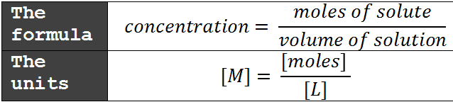

- What is the molarity of the solution produced when 145 g of sodium chloride is dissolved in sufficient water to prepare 2.75 L of solution?

- How many grams of potassium chloride are needed to prepare 0.750 L of 1.50 M KCl?

- To prepare 10.5 L of 2.50 M potassium hydroxide, how many grams of potassium hydroxide must be used?

For each pair of quantities mark < , =, or >.
Example: |  | The temperature in Madison today |  | __>__ |  | The temperature on a hot day on Mars
 | - the melting point of pure ice |  | ________ |  | The melting point of salty ice
 | - The boiling point of a 0.100 M solution of NaCl |  | ________ |  | The boiling point of a 0.200 M solution of NaCl
 | - The melting point of a 0.100 M solution of NaCl |  | ________ |  | The melting point of a 0.200 M solution of NaCl

