Acids with metals. Concentrations review.  CλeMis+ry: http://genest.weebly.com  Stop in for help every day at lunch and Tues, Weds., &Thurs after school!  After-hours question? Email me at home: eagenest@madison.k12.wi.us |  | Name_________  Period________

Metal with Acid
Remembering that Acid + Metal → hydrogen gas + salt, fill in the missing substances for each reaction below

- HBr + Na → _____ + _____
- HNO₃ + Mg →_____ + _____
- H₃PO₄ + Ca →_____ + _____
- We have three equations which we have been using in this chapter. :
Write the equation you have memorized that describes what number you get when you multiply the molarity of H+ by the molarity of OH- | Write the equation you have memorized that describes how H+ molarity is related to pH | Write the equation that you have been using since March to relate moles of solute, volume of solution, and molarity of a solution.

- If a solution contains 0.445 moles of HNO₃ dissolved to make 2.3 liters of solution, what is the molarity?

- If a solution of HF has a concentration of 2.3 x 10⁻⁶ M, and a volume of 444 mL, how many moles of HF does it have?

- In the reaction below, connect the conjugate pairs with a line. Write “acid” or “base” below each of the four substances.

NH₄⁺ + OH⁻ $⇆$ HOH + NH₃

- Show what reaction occurs when calcium reacts with HF. Use your periodic table to help you with the charges of the product so that the compound comes out with zero charge.
________ + __________ --> ________ + ________
- Write a word in the center of each circle to tell what color each would be. One has been done as an example. Use the dashed line table below as a reference.
 | PH = 3 | PH = 7 | PH = 11
phenolphthalein | Color -less  Color less
bromocresol green
Thymol blue

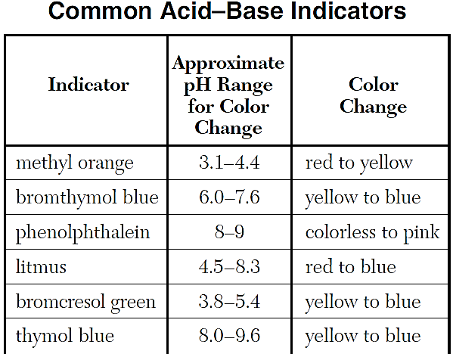
- Write the reaction equation for the reaction of magnesium and hydrogen chloride.

- Calculate both the concentration of H+ and of OH- ions at 25 degrees in
  - pure water

  - a 10. M solution of NaOH
- Find the [H+] of a solution at 25 degrees with a pH of
  - 3.494

  - 1.265

- If a solution contains 1.745 moles of HNO₃ dissolved to make 2.3 liters of solution, what is the molarity?

- IN the reactions below if water is behaving as a base, write “BASE', if water is behaving as an acid write “ACID”. Or write “NEITHER”.
  - NH₃ + H₂O → NH₄⁺ + OH- ______________________

  - H₂O + NH₂- → NH₃ + OH- ______________________

  - H+ + H₂O → H₃O+ ______________________

  - H- + H₂O → H₂ + OH- ______________________

The following four questions are all multiple choice:
- Circle the only two compounds that are electrolytes:
  - C₆H₁₂O₆
  - C₁₂H₂₂O₁₁
  - CH₃CH₂OH
  - HNO₃
  - NaOH
- A solution of HCl is a stronger acid than a solution of HCN because the HCl
  - creates a larger [OH-] in solution
  - creates a larger [H+] in solutions
  - has more mass than HCN
  - has less mass than HCN
- When tested, a solution turns red litmus to blue. This indicates that the solution contains more
  - H+ ions than OH- ions
  - H₃O+ ions than OH- ions
  - OH- ions than H₃O+ ions
  - H+ and OH- ions than H₂O molecules
- If an aqueous solution turns blue litmus red, which relationship exists between the hydronium ion and hydroxide ion?
  - [H₃O+] < [OH-]
  - [H₃O+] = [OH-]
  - [H₃O+] > [OH-]
  - Neither ion is present

