Wrong Lewis Dot Molecule Structures  CλeMis+ry: http://genest.weebly.com  Stop in for help every day at lunch and Tues,&Thurs after school! |  | Name_________  Period________

- Fill in the table
Circle atoms that are stable, cross out atoms that are unstable | Either write ‘stable’ or redraw the same letters in the same arrangement but with any number of e- that will make the atoms stable | Circle atoms that are stable, cross out atoms that are unstable | Either write ‘stable’ or redraw the same letters in the same arrangement but with any number of e- that will make the atoms stable
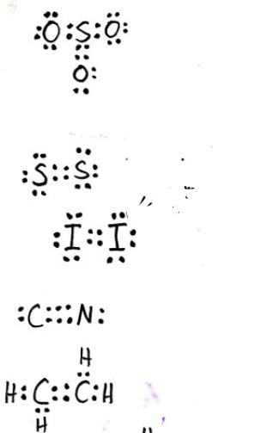 |  | 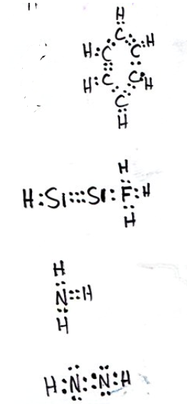

- Rewrite the following Noble Gas Abbreviations in the longer version of electron configuration (1s² 2s² etcetera)
  - [Ne]3s²3p²
  - [He]2s²2p¹
  - Write the Lewis Dot symbol for each of the two atoms above:

- Write a balanced equation for N³⁻ anion losing three electrons:
____ ____
- Write a balanced equation for Na+ ion gaining one electron:
____ ____

