Making Lewis Dot Molecule Structures  CλeMis+ry: http://genest.weebly.com  Stop in for help every day at lunch and Tues,&Thurs after school! | 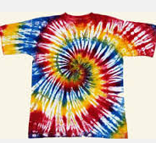 | Name_________  Period________

- Fill in the table
Circle atoms that are stable, cross out atoms that are unstable | Either write ‘stable’ or redraw the same letters in the same arrangement but with any number of e- that will make the atoms stable | Circle atoms that are stable, cross out atoms that are unstable | Either write ‘stable’ or redraw the same letters in the same arrangement but with any number of e- that will make the atoms stable
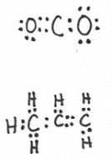 |  | 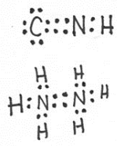

- Complete each step with the correct word or words.
In class we learned that the steps for drawing a Lewis Structure of a molecule are:
  - First, you total up the number of valence _______ on all of the atoms of the formula.
  - Then, when totaling up the e-, assume that each atom is (charged / neutral )
  - Next, place the element symbols on your drawing first, putting in the middle, any element that there are ( few of / lots of )
  - Now add electron dots (one at a time / two at a time ) to bond the atoms together
  - Add any leftover (protons / electrons ) as lone pairs
  - Check that each atom is stable and follows the ( trio / quartet / octet ) rule.
  - If you ran out of e-, you should erase some lone pairs and turn them into (single / double ) bonds.

- Draw a stable Lewis Dot structure for each molecule:
I₂ | OF₂
CO₂ | NI₃

- Rewrite the following Noble Gas Abbreviations in the longer version of electron configuration (1s² 2s² etcetera)
- [Ne]3s²3p⁵
- [He]2s¹
- Write the Lewis Dot symbol for each of the two atoms above:

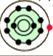 | - In the white box at right sketch Bohr Orbit diagram in a cartoon style similar to the one shown at left but make it different in two ways:  - Make it a sketch for the nitrogen atom with the ionization energy graph shown here  - where each electron should be, write a number that matches each of the numbered ionizations from the graph below
 |  | 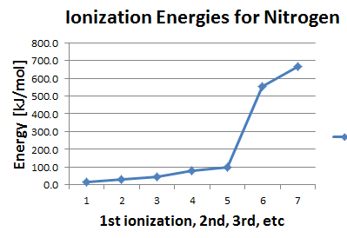

- What is the largest element in Period 3?

- What element is the smallest nobel gas?

- Which halogen has the second highest electronegativity?

- Draw a stable Lewis Dot structure for each molecule:
H₂S | N₂
HCl | F₂

