Guided Viewing for  Bill Nye’s 100 Greatest Chemistry Discoveries | 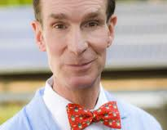 | Name ____________________  Period____________________  Date______________________
Today’s lesson:
1) Fill in this sheet while watching “Discovery: Greatest Chemistry Discoveries” starting at the 1:00 mark and finishing at 42:00 (total time 41minutes). [ link: https://www.youtube.com/watch?v=s7xxMX4Ovig ]
During the film jot notes in whatever way you feel comfortable in the white boxes.
2) After the video, fill in the quiz at the bottom of this sheet. The quiz will ask you about six of the scientists in the movie.
3) Turn this sheet in at the end of the hour

joseph priestley |  |  |  | 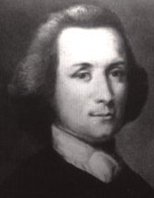
the Lavoissiers | 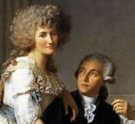
fredreich wohler |  | 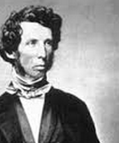
1 Dmitri Mendeleev |  |  |  | 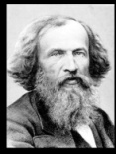
3 Robert Bunsen & Gustav Kirchoff |  |  |  | 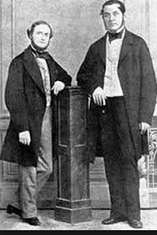
4 JJ Thomson |  |  |  | 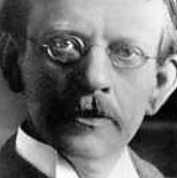
6 Gilbert Newton Lewis |  |  | 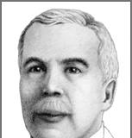

7 Henri Becquerel
8 Marie and Pierre Curie | 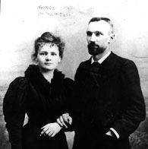
10 Richard Smalley | 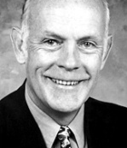

QUIZ ANSWERS: The teacher will give a little practice quiz after the movie. You should WRITE THE NAMES that match best in these boxES.
A |  | B |  | C
D |  | E |  | F
please place this sheet on the document camera projector as students enter the room
Warm Up: Get a guided viewing sheet.

- Next week’s test will include this sheet as open notes so do a good job.

- This sheet is due at the end of the period.

- During the video write notes next to each chemist’s picture.

- After the video the teacher will give an open notes quiz

you can place this sheet on the document camera projector after the video and students are accustomed to just turning in the sheet/quiz by walking up and putting it in a box that I place on top of the projector
Quiz “In your six boxes at the bottom of your notes sheet, write the names that match the following six scientist descriptions”
- Proposed that electrons are in shells around the atom. Stable atoms have a full valence shell (we just learned this in class)  - There’s no such thing as ‘living molecules’ and ‘nonliving molecules’ . Everything is just made of atoms – there’s no difference between atoms in living and nonliving things  - Discovered the strongest substance that will ever be discovered. Ever.  - Used a glowing glass tube and electricity to discover that atoms contain small negatively charged particles called electrons | - New elements can be discovered by spraying substances into a Bunsen burner and looking at the colors of the flame using a spectrum. Discovered cesium and rubidium. Discovered that the sun has atoms of sodium  - Organized the elements into a table with groups and rows (we now call this The Periodic Table)

