Predicting Molecular Geometry  CλeMis+ry: http://genest.weebly.com  Stop in for help every day at lunch and Tues,&Thurs after school! | 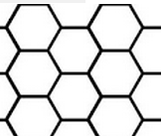 | Name_________  Period________
- Next to each, write the name of the geometric shape based on the central atom. You don’t have to memorize these names; you will always have your reference table for quizzes and tests.
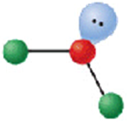 | 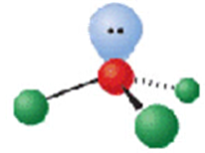 | 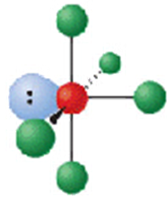 | 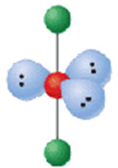
___________________ | ___________________ | ___________________ | ___________________

- Draw a stable Lewis Dot structure for each molecule AND THEN WRITE the name of the moleculaes geometry, based on the central atom:
NI₃  What’s the name of this geometry? | OF₂  What’s the name of this geometry?
CO₂  What’s the name of this geometry? | H₂O  What’s the name of this geometry?

- Write the electron configuration ( 1s² 2s²…) for each atom below
- an atom with 15 electrons

- a neutral iron atom

- What is the smallest element in Period 2?

- Which element in Group 2 has the highest electronegativity?

- Draw a stable Lewis Dot structure for each molecule:
CH₄  What’s the name of this geometry? | HCCH  What’s the name of this geometry?
SO₂  What’s the name of this geometry? | H₂CCH₂  What’s the name of this geometry?

- Draw a stable Lewis Dot structure for each molecule
N₂ | O₃

