Draw polar bonds  CλeMis+ry: http://genest.weebly.com  Stop in for help every day at lunch and Tues,&Thurs after school! | look up Mach Illusion on the internet | Name_________  Period________
- According to your electronegativity table, what is the exact electronegativity of each element below?

  - beryllium
  - phosphorous
  - calcium
  - fluorine

- Calculate the number of valence e- in each of the following:

- SO₄²⁻
- NH₄⁺
- CH₃O₂⁺
- ClO₃ –

- Next to each atom, write the electronegativity value from your table. Then draw an arrow to show the direction of polarity of the bond. Finally, write the symbols for partial positive and negative.δ+ and δ-.

- Why does your table not have electronegativity numbers for the nobel gases?

- Next to each, write the name of the geometric shape based on the central atom. Assume each line is a connection between two atoms.
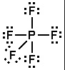 | 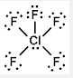 | 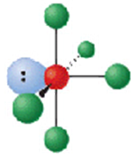 | 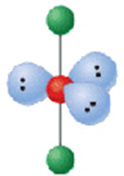
___________________ | ___________________ | ___________________ | ___________________

- Draw a stable Lewis Dot structure for each molecule AND THEN WRITE the name of the moleculaes geometry, based on the central atom:
- NF₃  What’s the name of this geometry? | - SO₄²⁻  What’s the name of this geometry?
NH₄⁺  What’s the name of this geometry? | ClO₃ –  What’s the name of this geometry?

- How many total valence e- are in each of the following?

  - I₃⁻
  - CO₃²⁻
  - PO₄³⁻
  - NO₃⁻

- Which element in Group 2 has the largest radius?
- Which element in Period 2 has the largest radius?

- Draw a stable Lewis Dot structure for each molecule:
I₃⁻  What’s the name of this geometry? | CO₃²⁻  What’s the name of this geometry?
NO₃⁻  What’s the name of this geometry? | SCl₂  What’s the name of this geometry?

