Exceptions to the Octet Rule  CλeMis+ry: http://genest.weebly.com  Stop in for help every day at lunch and Tues,&Thurs after school! |  | Name_________  Period________
- How many protons_______ and neutrons __________ are in:
$${}_{15}^{32}P$$

- How many valence electrons are in each of the following?

1s²2s²2p⁵ | a +1 cation of sodium | 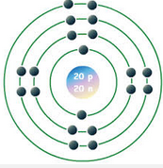 | 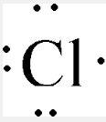 | a neutral carbon atom
_________ | __________ | __________ | __________ | __________

How many protons and neutrons are in:
$${}_{15}^{32}P$$

- For an atom with atomic number =9, charge of zero, and 10 neutrons…
  - mass number _______
  - number of protons? ______
  - number of electrons ______
  - symbol of the element, with highLow numbers ______
- For an atom with 14 protons and 15 neutrons and 18 electrons
  - mass number ______
  - atomic number ______
  - number of electrons ______
  - symbol of the element ______
  - charge of the atom ______
  - symbol of the element, with highLow numbers ______
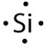 | - For this atom,  - how many total electrons ?  - how many protons?  - how many valence electrons?

- What is true about the number of particles in an atom that has a neutral charge?

- What is true about the number of particles in any cation?

- Write the formula for finding mass number of an atom.

- Write the formula for finding the charge of an atom.

- In the after box redraw what this atom will look like after losing two electrons.  The charge before ________  The charge after __________  It became a ( anion / cation ) | Before  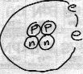 |  | After | HighLow Letter symbol for the after atom?

- Which element in Group 1 has the largest radius?
- Which element in Period 1 has the largest radius?
- The Law of Conservation of Energy says that if nothing enters or leaves a system, the total __________ in that system must be the same before and after any change.
Use this law to spot any fibs below:

- ( possible / impossible )  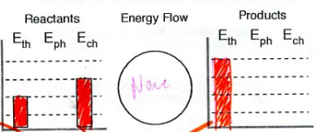 | - ( possible / impossible )  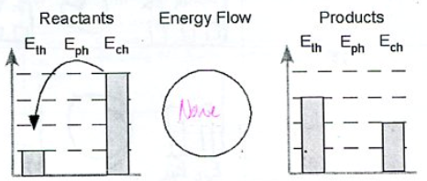

- The Law of Conservation of Charge is similar to the two laws above. It says that if nothing enters or leaves a system, the total ____________ in that system must be the same before and after any change.

- The Law of Conservation of Charge can help us spot wrongly written equations for ions.
  - Ba + 2e- Ba²⁺ possible / impossible
  - F F+ + e- possible / impossible
  - S S²⁺ + 2e- possible / impossible

- Draw a stable Lewis Dot structure for each molecule:
I₃⁻  What’s the name of this geometry? | CO₃²⁻  What’s the name of this geometry?

