Review #2  CλeMis+ry: http://genest.weebly.com  Stop in for help every day at lunch and Tues,&Thurs after school! |  | Name_________  Period________
(Review #1 was the puzzle pieces sheet.)

- Write a balanced equation for S²⁻ anion losing two electrons:
____ ____ + ____
- Write a balanced equation for the only stable calcium ion gaining two electrons:
____ + ____ ____
In the after box redraw what this atom will look like after losing one electron.  The charge before ________  The charge after __________  It became a (anion / cation ) | Before  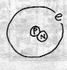 |  | After | HighLow Letter symbol for the after atom?
In the after box redraw what this atom will look like after gaining one electron.  The charge before ________  The charge after __________ | Before  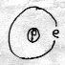 |  | After | HighLow Letter symbol for the after atom?

- Draw the Bohr model atom 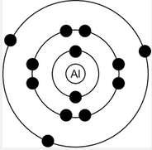 for each of the following:
1s²2s²2p¹ | a +2 cation of magnesium | 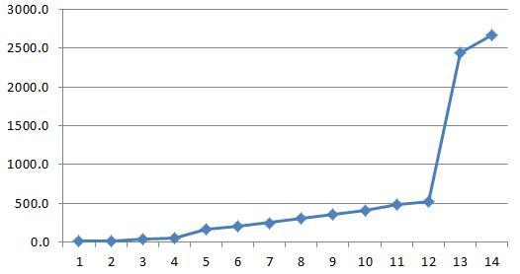

- With the help of your Rewrite [Ar]4s²3d¹⁰4p⁴ in the longer version of electron configuration (1s² 2s² etcetera)

Draw the Bohr diagram for the following three atoms. Label how many protons each has in its nucleus.
neutral helium | neutral lithium | neutral neon

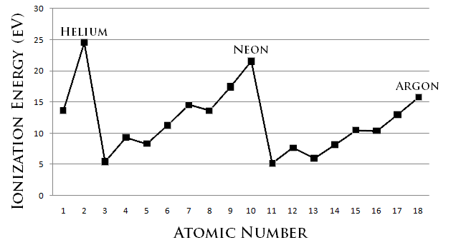

Use the information in the box above to answer the following seven questions.
- Going from lithium to beryllium removing a valence electron becomes
  - easier
  - more difficult
  - there’s no difference
- Explain what structural feature causes element 2 to be harder to ionize than element 3.

- Explain what structural feature causes element 4 to be harder to ionize than element 3.

- Circle the element in each pair with a greater radius
  - Al or Cl
  - K or Ca
  - H or He
- Explain what structural feature is the cause of the difference in radius in each pair above?

- Circle the element in each pair with a greater radius
  - N or As
  - Cs or K
  - Ar or Xe
- Explain what structural feature is the cause of the difference in radius in each pair above?

- for a NEUTRAL atom with the following electron configuration:
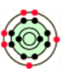
Tell how many e- are in each energy level
1st: 2nd: 3rd: 4th: 5th:
This atom has ________ valence e-
therefore it is (stable / unstable )
Write a Lewis dot diagram (Letter and dots)

Write the last name of each chemist next to the description
- ______________ was astonished to find that a ‘living substance’ (urea) can form from nonliving substances (cyanic acid and ammonia).
- ______________ Wrote a textbook to help his students memorize the elements more easily.
- ______________ Invented the spectroscope. Discovered that the sun contains sodium.

- When neutral 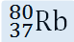changes into Rb⁺ ion, the numbers of some particle(s) change.
- has _______ protons _______ electrons _______ neutrons
- Rb⁺ ion has _______ protons _______ electrons _______ neutrons

- for a NEUTRAL atom with the following electron configuration:
1s²2s²2p⁶3s²3p⁶4s²3d¹⁰4p⁶5s²4d¹⁰5p³

Tell how many e- are in each energy level
1st: 2nd: 3rd: 4th: 5th:
This atom has ________ valence e-
therefore it is (stable / unstable )
Write a Lewis dot diagram (Letter and dots)

- For an atom with 8 electrons, 10 protons, and 12 neutrons,
Draw the Bohr orbital | Write the Lewis dot abbreviation | Write the atom symbol with highLow numbers | Does this atom have a stable valence orbital?

- for a NEUTRAL atom with the following electron configuration:
1s²2s²2p⁶3s²3p⁶4s²3d⁵

Tell how many e- are in each energy level
1st: 2nd: 3rd: 4th: 5th:
This atom has ________ valence e-
therefore it is (stable / unstable )
Write a Lewis dot diagram (Letter and dots)

- How many valence electrons are in each of the following?

1s²2s²2p⁶3s²3p⁶4s²3d⁵ | 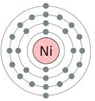 | an atom with 24 protons and 19 electrons | a -2 anion of oxygen | a neutral  atom
_________ | __________ | __________ | __________ | __________

