HInt: Remember that (metal) (nonmetal) = ionic (nonmetal)(nonmetal) = molecular
warmup, just fill in this box:
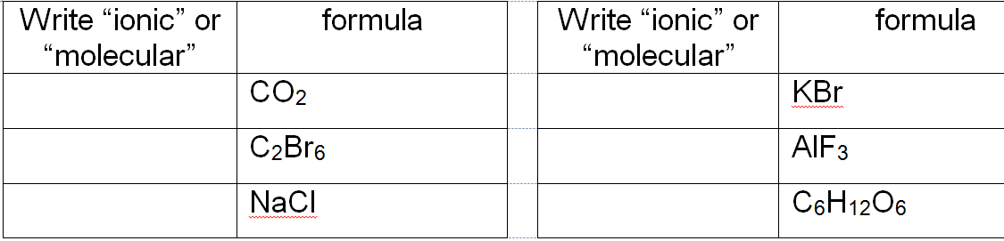
- Predictions
  - ___________________________________________________________________________
  - ____________________________________________________________________________
  - ____________________________________________________________________________
- Pure Water –
____________________________________________________________________________
- Electrolytes
  - ____________________________________________________________________________
  - ____________________________________________________________________________
- Electrolytes look like this: Nonelectrolytes look like this:

Compound | Metal Present? | Ionic or  Covalent? | Show the one OR MORE particles it makes when dissolved in water  (you can often just chop off the metal part from the left OR you may like using a table of common ions for help) | Is it an electrolyte?
MgCl₂
KNO₃
CF₄
CaF₂

