Inside the atom are nucleons classwork  CλeMis+ry | 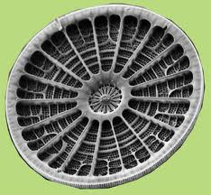 | Name_____________________  Date______________________  Period____________________
notes [save! memorize by Friday!]:

Each figure is a flawed attempt to show what a single atom looks like. None are correct. But we like them because they are easy ways to draw something that is undrawable.
Directions: Above each box, label the NUCLEONS and the ELECTRONS
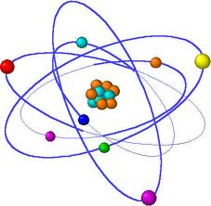 |  | 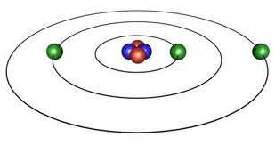 |  | 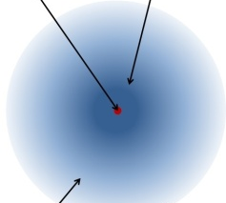 |  | 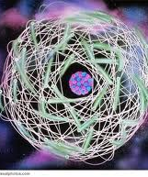

If this atom has ____ protons and ____ neutrons it is the element _________.  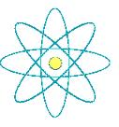  Mass number _______  Symbol of the element ______ |  | If this atom has ____ protons and ____ neutrons  it is the element _________.  And it weighs _______ a.m.u.  Symbol of the element ______ |  | If an atom has 22 protons it is the element _________.  If the atomic number is 34 the atom must have ______ protons.  If an atom has 79 protons it is the element _________.  If the atomic number is 85 the atom must have ______ protons.

mass number rule: |  | charge rule:

- If an atom has 12 protons and 10 neutrons, how many nucleons does it have? ____________
- If an atom has 5 protons and 6 neutrons what is the mass of the atom? ________
- If an atom is oxygen how many protons does it have? ________
- If an atom has 4 protons what element is it? ______________
- If an atom weighs 12 amu's how many nucleons does it have? _______________
- If an atom has 2 protons and it has 5 nucleons, how many neutrons does it have? ____________
- If an atom has 40 nucleons and has 10 neutrons, how many protons does it have? ____________
- For an atom with atomic number =9, charge of zero, and 10 neutrons…
  - mass number _______
  - number of protons? ______
  - number of electrons ______
  - symbol of the element, with highLow numbers ______
- For an atom with 14 protons and 15 neutrons and 18 electrons
  - mass number ______
  - atomic number ______
  - number of electrons ______
  - symbol of the element ______
  - charge of the atom ______
  - symbol of the element, with highLow numbers ______

- For a neutral atom with mass number of 47, 25 neutrons, and 22 electrons
  - atomic number ______
  - number of protons ______
  - number of electrons ______
  - symbol of the element, with highLow numbers ______
- For an atom with mass number 55, and has 25 protons and 23 electrons
  - charge ______
  - atomic number ______
  - number of neutrons ______
  - symbol of the element, with highLow numbers ______

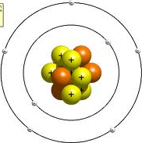  Homework:  - If an atom has 12 protons and 10 neutrons, it has a mass of ______ and it is the element __________.  - If an atom has 1 proton and 0 neutrons, and 2 electrons, what is the highLow symbol of the atom? ________  - If an atom is helium how many protons does it have? ___________  - If an atom has 10 protons what element is it? ______________  - If the atom’s mass number is 18 how many nucleons does it have?  - If an atom has 12 protons and it has 25 nucleons, how many neutrons does it have? ____________  - If an atom has 20 nucleons and has 9 neutrons, how many protons does it have? ____________  - If an atom has 1 proton and 0 neutrons what element is it? ________  - If an atom has 22 protons and 20 neutrons, and 20 electrons, write the highLow symbol with charge __________.  - If an atom has 8 proton and 11 neutrons what is the mass of the atom? ________  - If an atom is magnesium how many protons does it have? ___________  - If an atom has 15 protons what element is it? ______________  - If an atom mass number is 28 amu's and there are 12 neutrons, what element is it?  - If an atom has 6 protons and it has 10 nucleons, how many neutrons does it have? ____________  - If an atom has 1 nucleon and has zero neutrons, how many protons does it have? ____________  - If an atom has 92 protons, 91 electrons, and 146 neutrons write the symbol, with highLow numbers and charge ________ | Homework:  - If an atom has 12 protons and 10 neutrons, it has a mass of ______ and it is the element __________.  - If an atom has 1 proton and 0 neutrons, and 2 electrons, what is the highLow symbol of the atom? ________  - If an atom is helium how many protons does it have? ___________  - If an atom has 10 protons what element is it? ______________  - If the atom’s mass number is 18 how many nucleons does it have?  - If an atom has 12 protons and it has 25 nucleons, how many neutrons does it have? ____________  - If an atom has 20 nucleons and has 9 neutrons, how many protons does it have? ____________  - If an atom has 1 proton and 0 neutrons what element is it? ________  - If an atom has 22 protons and 20 neutrons, and 20 electrons, write the highLow symbol with charge __________.  - If an atom has 8 proton and 11 neutrons what is the mass of the atom? ________  - If an atom is magnesium how many protons does it have? ___________  - If an atom has 15 protons what element is it? ______________  - If an atom mass number is 28 amu's and there are 12 neutrons, what element is it?  - If an atom has 6 protons and it has 10 nucleons, how many neutrons does it have? ____________  - If an atom has 1 nucleon and has zero neutrons, how many protons does it have? ____________  - If an atom has 92 protons, 91 electrons, and 146 neutrons write the symbol, with highLow numbers and charge ________

p l a n

MON
Warm-up:
The tininess of atoms: get a pair of scissors, cut a paper in half as many times as possible.*

the skin of an atom has one or more electrons
the middle of an atom has protons and neutrons.

the mass is measured in a.m.u.

Both protons and neutrons weigh ~ one a.m.u. each.

Every time you add a proton that is a new element.

The mass number of an atom is P + n = mass number
The charge is charge = P - e

shorten the length by half, 31 times.
You will have the size of a single atom.
assumptions: aluminum atom radius is 0.143 nm
28 cm / 2^n = 0.143 x 10-7 cm

