How do we show ionization?  CλeMis+ry: http://genest.weebly.com  Stop in for help every day at lunch and Tues,&Thurs after school!  After-hours question? Email me at home: eagenest@madison.k12.wi.us | 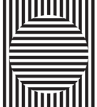 | Name_________  Period________

- Define ionization.

- What is true about the number of particles in an atom that has a neutral charge?

- What is true about the number of particles in any cation?

- What is true about the number of particles in any anion?

- Circle the ion that each element below forms when in a compound:
  - Calcium: Ca ⁺ Ca²⁺ Ca³⁺
  - Aluminum Al⁺ Al²⁺ Al³⁺
  - Oxygen: O⁻ O²⁻ O³⁻
In the after box redraw what this atom will look like after gaining two electrons.  The charge before ________  The charge after __________  It became a (anion / cation ) | Before  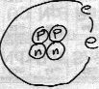 |  | After | HighLow Letter symbol for the after atom?
In the after box redraw what this atom will look like after losing two electrons.  The charge before ________  The charge after __________  It became a ( anion / cation ) | Before |  | After | HighLow Letter symbol for the after atom?
In the after box redraw what this atom will look like after losing one electron.  The charge before ________  The charge after __________  It became a (anion / cation ) | Before  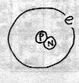 |  | After | HighLow Letter symbol for the after atom?
In the after box redraw what this atom will look like after gaining one electron.  The charge before ________  The charge after __________ | Before  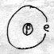 |  | After | HighLow Letter symbol for the after atom?
For the previous four questions, draw an ionization equation, similar to A + e- -> A- or A -> A+ + e-

- _____________________________________________
- _____________________________________________
- _____________________________________________
- _____________________________________________

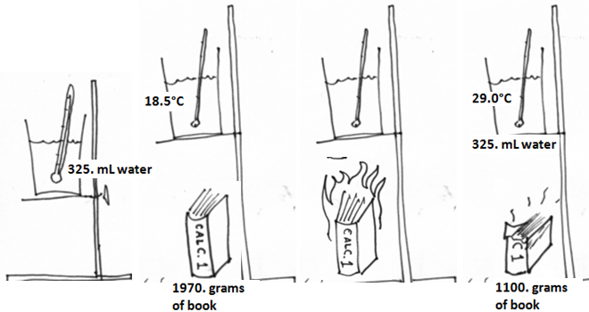

If the formula of ‘book’ is C₆H₁₂O₆, find how many moles of book burned | Recall that Cp for water is 4.18 J/g-°C  Q = m c_{p} ∆T  Find how many kilojoules went into the water
Use ratios to find how much heat would come out from burning 1 mole of book:

$$\frac{your joules}{your moles} = \frac{x}{1 mole}$$

- If an atom is helium how many protons does it have? ___________
- If an atom has 10 protons what element is it? ______________
- If the atom’s mass number is 18 how many nucleons does it have?

