Ionization II  CλeMis+ry: http://genest.weebly.com  Stop in for help every day at lunch and Tues,&Thurs after school! |  | Name_________  Period________

- The Law of Conservation of Mass says that if nothing enters or leaves a system, the total ___________ in that system must be the same before and after any change.
Based on this Law, mark the following as possible or not:

- If a reaction of A + B C + D ( possible / impossible )
30g 14g 40g 8g

- If a reaction of W + X Y + Z ( possible / impossible )
14g 16g 15g 15g

- For a dissolving reaction: Na₂CO_{3(s)} Na⁺_{(aq)} + CO₃²⁻_{(aq)} ( possible / impossible )

- The Law of Conservation of Energy says that if nothing enters or leaves a system, the total __________ in that system must be the same before and after any change.
Use this law to spot any fibs below:

- ( possible / impossible )  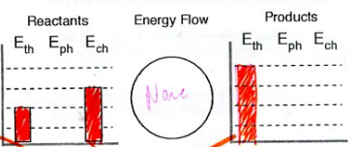 | - ( possible / impossible )  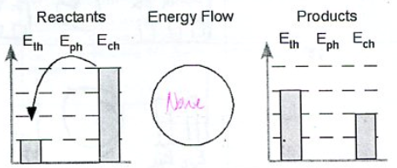

- The Law of Conservation of Charge is similar to the two laws above. It says that if nothing enters or leaves a system, the total ____________ in that system must be the same before and after any change.

- The Law of Conservation of Charge can help us spot wrongly written equations for ions.
  - Ba + 2e- Ba²⁺ possible / impossible
  - F F+ + e- possible / impossible
  - S S²⁺ + 2e- possible / impossible
  - I I⁺ + e- possible / impossible
  - Ag + e- Ag⁺ possible / impossible

- Write a balanced equation for neutral Mg losing two electrons (In the first blank, write Mg. You don’t need to write the high low numbers, just the charge, if any):
____ ____ + ____
- Write a balanced equation for neutral chlorine atom gaining one electron:
____ + ____ ____

- Write a balanced equation for a neutral boron atom losing three electrons:
____ ____ + ____
- Write a balanced equation for O²⁻ anion losing two electrons:
____ ____ + ____
- Write a balanced equation for Iron(III) ion gaining three electrons:
____ + ____ ____

Valence
- How many valence electrons does each atom below have?
 | ________ |  | _________
Below each particle group circle the total charge
- 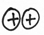 | - 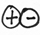
( -2 / -1 / neutral / +1 / +2 ) | ( -2 / -1 / neutral / +1 / +2 ) | ( -2 / -1 / neutral / +1 / +2 ) | ( -2 / -1 / neutral / +1 / +2 )

- For electrically charged objects, the two principles of attraction are:
- attraction decreases with distance
- attraction decreases when charge decreases
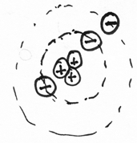 | - In this drawing of an atom the particles are labeled with their charges. This atom contains _______ electrons, ______ protons, and ______ neutrons.

- How many valence electrons does each atom below have?
 | ________ |  | _________

- In which situation below will attraction be stronger? ( A / B / no difference ) |  | - In which situation below will attraction be stronger? ( A / B / no difference )

- In which situation below will attraction be stronger? ( A / B / no difference ) |  | - In which situation below will attraction be stronger? ( A / B / no difference )

- To remove an electron from an atom we have to pull hard enough to overcome the attraction of the atom’s nucleus. On the two atoms below, which has a valence electron that is easiest to remove? ( A / B )
A |  | B

