Apply Rules for Atomic Trends  CλeMis+ry: http://genest.weebly.com  Stop in for help every day at lunch and Tues,&Thurs after school!  Our last Test will be Friday, May 27. |  | Name_________  Period________

All Trends

Draw on this Periodic Table some arrows and numbers with a crayon or marker to show the following
- Show which direction in a period the ionization energies increase
- Show which direction in a period the atomic radius increases
- Show which direction in a period the electronegativity increases
- Show which direction in a period the charge of the nucleus increases
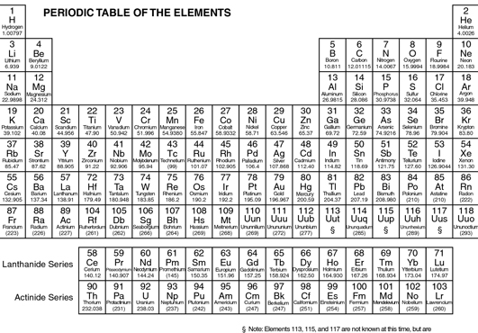

Nuclear Charge Trends.

- This is a measure of how many positive charges are in the nucleus of the atom.
- How many protons are in the nucleus of sodium? _________
- What is the total positive charge of the nucleus of a sodium atom? _________
- In each pair, circle the element that has a greater nucleus charge.
- Neon or Helium
- Hydrogen or Helium
- Gold or Silver

Atomic Radius Trends.

- In each pair, circle the element that has a greater radius.
- Neon or Helium
- Hydrogen or Helium
- Magnesium or Potassium
- Write a balanced equation for neutral fluorine atom gaining one electron:

____ + ____ ____

- Write a balanced equation for S²⁻ anion losing two electrons:

____ ____ + ____

Electronegativity Trends.
- In each pair, circle the element that has a greater electronegativity.
- phosphorous or chlorine
- phosphorous or antimony
- fluorine or iodine

Ionization Energy Trends.

- In each pair, circle the element that has a greater electronegativity.
- sodium or lithium
- iron or zinc
- oxygen or phosphorous

Ion Radius Trends.
- When we speak of ion radius, we speak of their most common ions.
The ions for metals are usually ( negative / postitive ). The common ions for nonmetals are ( negative / postitive ).

Draw on this Periodic Table some arrows with a crayon or marker to show the following

- Show which direction in a group the ionization energies increase
- Show which direction in a group the atomic radius increases
- Show which direction in a group the electronegativity increases
- Show which direction in a group the charge of the nucleus increases

- Remember, for electrically charged objects, the two principles of force are:
- attraction decreases with distance
- attraction decreases when charge decreases
In each pair, circle the pair that has a greater attraction.
- an electron and proton that are 2 nanometers apart or an electron and proton that are 3 nanometers apart
- an electron and the nucleus of nitrogen or an electron and the nucleus of oxygen
Below each particle group circle the total charge
- 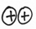 | - 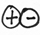
( -2 / -1 / neutral / +1 / +2 ) | ( -2 / -1 / neutral / +1 / +2 ) | ( -2 / -1 / neutral / +1 / +2 ) | ( -2 / -1 / neutral / +1 / +2 )

- In which situation below will attraction be stronger? ( A / B / no difference ) |  | - In which situation below will attraction be stronger? ( A / B / no difference )

- In which situation below will attraction be stronger? ( A / B / no difference ) |  | - In which situation below will attraction be stronger? ( A / B / no difference )

- For which of these proper4ties does aluminum have a greater value than chlorine?
- first ionization energy?
- atomic radius?
- electronegativity?

- Arrange these elements in order of decreasing atomic size: gold, platinum, mercury.

- How does the radius of a cation compare with the radius of the neutral atom of the same element?

- Arrange these elements in order of decreasing ionization energy: nitrogen, zinc, phosphorous .

- Write a balanced equation for a calcium ion losing two electrons:

____ + ____ ____

