Name___________________________
- Electrons that are easy to remove are probably ( close to / far from ) the nucleus.  - Choose one. All else being equal, removing an electron will be tougher in which situation?  - when the nucleus of the atom has 5 protons  - when the nucleus of the atom has 6 protons  - This is data for removing five electrons from an atom:  - If this had charge of zero at first and had 5 electrons at first, how many protons did it have? (use your formula) _______  - What element is this? _________  - On this graph, next to all five dots write words similar to CLOSE or FAR or OTHER WORDS to describe where you think the electron is compared to the nucleus.  - Wherever it fits or on other paper, draw a Bohr-style picture (Look at today’s class notes) of boron’s nucleus and how close its electron rings are to the nucleus. Number the electrons 1, 2, 3, 4, & 5 to match the five electrons from the graph above. | - If electrons are smiley faces, in which case is the outermost electron tougher to remove?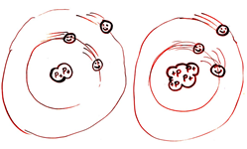  - On this graph, next to all eleven dots write words similar to CLOSE or FAR or OTHER WORDS to describe where you think the electron is compared to the nucleus.  - Wherever it fits or on other paper, draw a Bohr-style picture (Look at today’s class notes) of boron’s nucleus and how close its electron rings are to the nucleus. Number the electrons 1, 2, 3… to match the eleven electrons from the graph above.

- If electrons are smiley faces, in which case is the outermost electron tougher to remove?  Atom A or Atom B?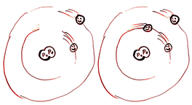  - One this graph, next to all twenty dots write words similar to CLOSE or FAR or OTHER WORDS to describe where you think the electron is compared to the nucleus.  - Wherever it fits or on other paper,, draw a Bohr-style picture (Look at today’s class notes) of boron’s nucleus and how close its electron rings are to the nucleus. Number the electrons 1, 2, 3… to match the twenty electrons from the graph above. | - Circle the atom that has more protons in the nucleus: Liuthium or Beryllium  - Circle the atom that has the greater radius: Lithium or Beryllium.  - Circle the atom that has more protons in the nucleus: fluorine or sodium  - Circle the atom that has the greater radius: fluorine or sodium.  - Circle correct words: “Going from Na to Mg, the radius gets ( smaller / larger ) and there are ( less / more ) protons.  - Circle correct words: “Going from F to Na, the radius gets ( smaller / larger ) and there are ( less / more ) protons.  - Make a rule: “When an element has more protons in the nucleus..  