Ionization Energy for removing all the electrons from BORON, one by one
Below are graphs of the ionization energies for BORON.
Two definitions to memorize:
Electron Affinity is defined as the energy required to add an electron to an atom.
Ionization energy is defined as the energy required to remove an electron from an atom. It is not the energy for adding an electron.
The graphs here are for ionization energy only.

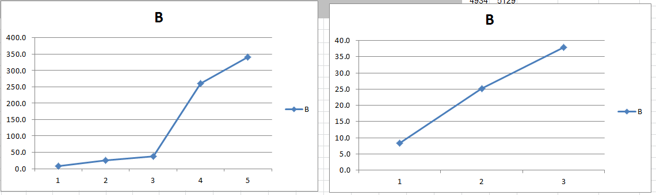

Ionization Energy for removing all the electrons from SODIUM, one by one
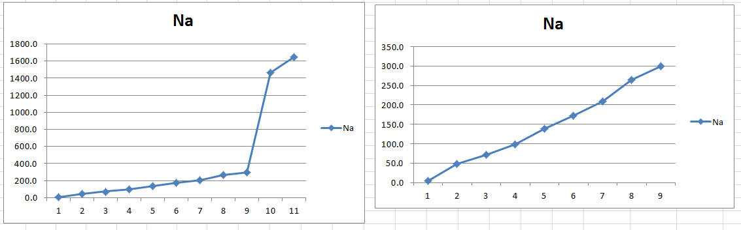

Ionization Energy for removing all the electrons from Calcium, one by one
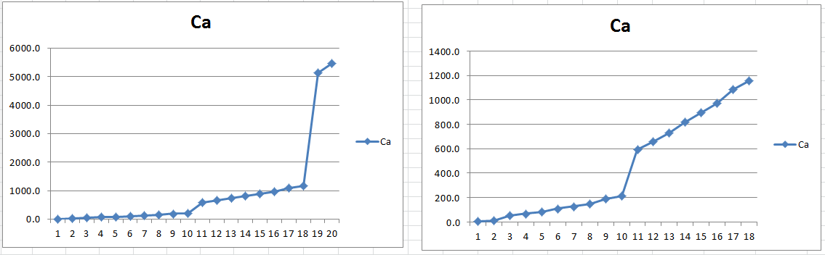

Ionization Energy for removing all the electrons from ________ one by one

