Where are the electrons? Why the trends?  CλeMis+ry: http://genest.weebly.com  Stop in for help every day at lunch and Tues,&Thurs after school! |  | Name_________  Period________

Periods and Groups

- How many elements are in Group 1?
- How many elements are in Group 18?
- How many elements are in Period 2?
- What is the Group name for Group 1?
- What is the Group name for Group 18?

- Which should be harder to remove,
  - an electron that is close to the nucleus
  - an electron that is far from the nucleus
- Which should be harder to remove,
  - an electron that is in an atom with 5 protons
  - an electron that is in an atom with 6 protons

- Next to each data point, depending on how strongly the nucleus attracts that electron, write a letter for (S)trong or (W)eak.or (M)edium. | 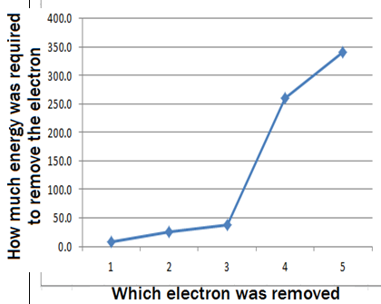 | - Now, next to each data point, based on your answers so far, either write (F)ar or (C)lose next to each data point, to indicate that electron’s distance from the nucleus.

- Look at your notes from today. How does the atomic radius change as going from left to right on the periodic table? It mostly ( shrinks / stays the same / grows )

- How does the atomic radius change as going from hydrogen to lithium to sodium on the periodic table? It mostly ( shrinks / stays the same / grows )

- For full credit, answer in an a complete sentence. Why is sodium larger than lithium?

- For full credit, answer in an a complete sentence. Why is sodium larger than magnesium?

- Look at the pattern from electron #3 to electron #10 and then how it repeats from #11 to #18 . In the grey space to the right, extend the pattern by drawing where you think the next four dots should be . Be brave!

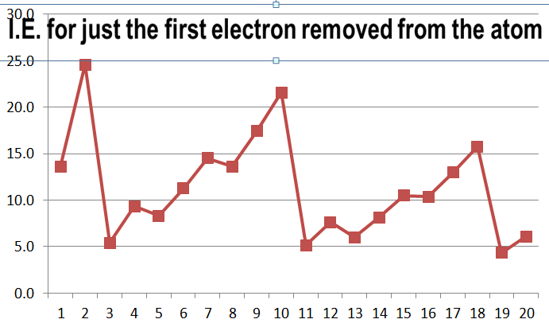21 22 23 24

- According to this chart, which requires more energy removing one electron from Beryllium or Lithium?  Arrange these three elements in order, from easiest to ionize to most difficult.  {He, Li, Be}  __________________________  Why does the trend for I.E. for these three elements go down and then up again? (explain using words & pictures) | 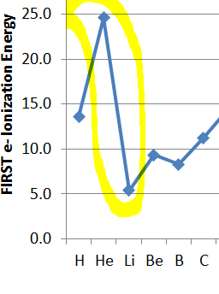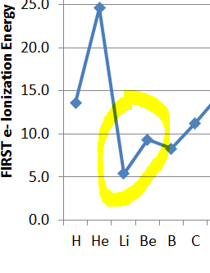
- (p. 398 in the textbook. The textbook is available at the class website next to today’s date) How does XRay diffraction provide an estimate of the distance between two nuclei?

- From p. 398, copy just the picture of the two atoms, with the words ‘Distance…’ , ‘Nucleus’, & ‘Atomic Radius’. Don’t copy the seven diatomic element pictures.

- In the white box at right sketch an atom in a cartoon style similar to the one shown at left but make it different in two ways:
- Make it a sketch for the nitrogen atom with the ionization energy graph below
- where each electron should be, write a number that matches each of the numbered ionizations from the graph below
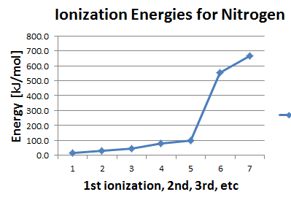

- In the white box sketch an atom in a cartoon style similar to the one shown here but make it different in two ways:
- Make it a sketch for the magnesium atom with the ionization energy graph shown below
- where each electron should be, write a number that matches each of the numbered ionizations from the graph below
