Conjugate Acids + Indicators  EHS Cλ3MIs+rγ  Mr. Genest | Andrew’s car | Name____________________  Date____________________  .
- In each case below for any substance on the LEFT side of the arrow, mark it as follows: circle any acid, underline any base, cross out anything that is neither an acid nor a base. (If you are stuck, look at the example on Question #10)

  - HSO₄⁻ + H₂O --> SO₄²⁻ + H₃O⁺
  - H₂O + NH₃ OH⁻ NH₄⁺
  - H₃PO₄ + NH₃ NH₄⁺ + H₂PO₄⁻
  - H₂PO₄⁻ + H₂O HPO₄²⁻ H₃O⁺

- What color is phenolphthalein in very basic solution?

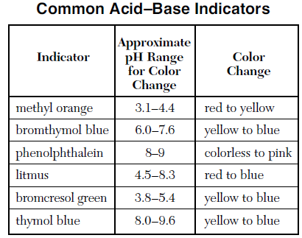
- A sample of a solution with a pH of 10 is tested separately with phenolphthalein and litmus indicator. The colors of the indicators are as follows (choose only one letter )
  - litmus is blue; phenolphthalein is pink
  - litmus is red; phenolphthalein is pink
  - litmus is blue; phenolphthalein is colorless
  - litmus is red; phenolphthalein is colorless

- What color is phenolphtalein in a beaker full of concentrated H₂SO₄?

- A blue solution containing an acid-base indicator was tested with a pH meter and found to have a pH of 5.5. Which of the indicators shown on the table above could be this indicator?

- A solution was yellow in bromthymol blue and blue in bromcresol green. According to the table here, what could be the pH of this solution?

- Acid was added to a solution containing an indicator until the solution turned from blue to yellow. Which of the following would be the most acidic?
- a yellow solution containing bromthymol blue
- a yellow solution containing bromcresol green
- a yellow solution containing thymol blue
- Complete and balance the neutralization reaction for

  - HI neutralizing Mg(OH)₂
  - Al(OH)₃ is mixed with HCH₃COO

- If NH₃ is a base, what is its conjugate acid?

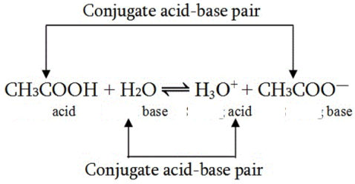
- Using this diagram as a model, draw a complete reaction for each pair below. Label them with the arrows and all of the words shown in this diagram
Ca(OH)2 reacting with HCHOO

- If a beaker contains 0.00000593 moles of H+ ions, in 30.0 L of water,
- What is the [H+]?

- what is the pH?

- If a beaker contains 4.89x10¹⁴ H+ ions, in 0.790 liters of water,
- What is the [H+]?

- what is the pH?

- find the number of H+ ions that would be in a 690.mL (units!) volume of a solution that had the same molarity you found in answer A.

- In each case below for any substance on the LEFT side of the arrow, mark it as follows: circle any acid, underline any base, cross out anything that is neither an acid nor a base.

  - SO₄²⁻ + H₃O⁺ HSO₄⁻ + H₂O

  - NH₄⁺ + H₂PO₄⁻ H₃PO₄ + NH₃

