electron configuration diagram. you will have this available for quizzes and tests.
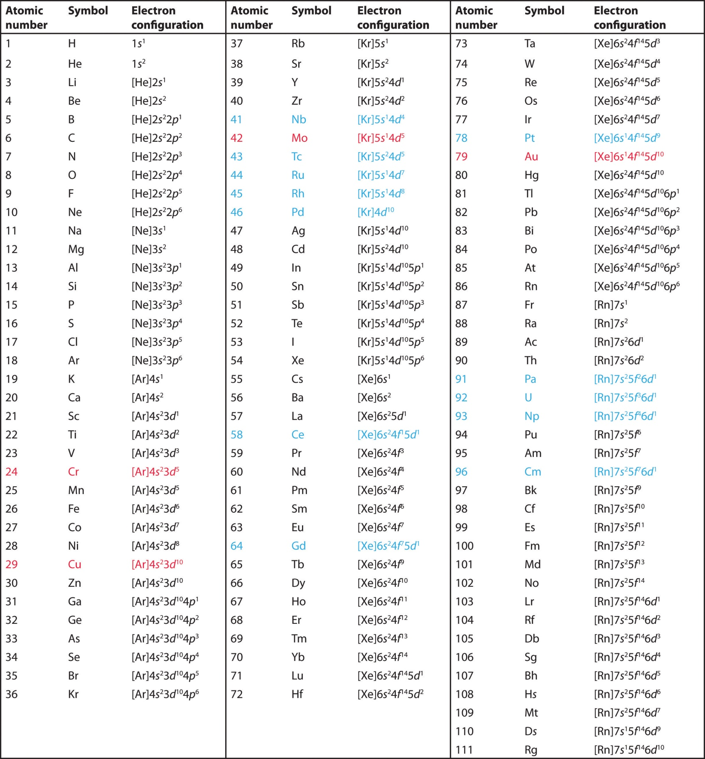
Keep this handy for
classwork and homework.
1s22s2 To Lewis Dot  CλeMis+ry: http://genest.weebly.com  Stop in for help every day at lunch and Tues,&Thurs after school! |  | Name_________  Period________

- Rewrite the following Noble Gas Abbreviations in the longer version of electron configuration (1s² 2s² etcetera)
  - [Ar]4s²3d²
  - [He]2s²2p⁵
  - Write the Lewis Dot symbol for each of the two atoms above:

- for a NEUTRAL atom with the following electron configuration:
1s²2s²2p⁶3s²3p⁶4s²3d¹⁰4p²

Draw a Bohr orbital diagram (the circles) | Write a Lewis dot diagram (Letter and dots) | This atom has ________ valence e-  therefore it is (stable / unstable )

- for a NEUTRAL atom with the following electron configuration:
1s²2s²2p⁶3s²3p⁶4s¹

Tell how many e- are in each energy level
1st: 2nd: 3rd: 4th: 5th:
This atom has ________ valence e-
therefore it is (stable / unstable )
Write a Lewis dot diagram (Letter and dots)

- With the help of your Rewrite the following Noble Gas Abbreviations in the longer version of electron configuration (1s² 2s² etcetera)
  - [Ar]4s²3d¹⁰4p⁴ _________________________________________________________
  - [He]2s²2p⁵ _________________________________________________________
  - Write the Lewis Dot symbol for each of the two atoms above:

- for a NEUTRAL atom with the following electron configuration:
1s²2s²2p⁶3s²3p⁶4s²3d¹⁰4p⁶5s²4d¹⁰5p³

Tell how many e- are in each energy level
1st: 2nd: 3rd: 4th: 5th:
This atom has ________ valence e-
therefore it is (stable / unstable )
Write a Lewis dot diagram (Letter and dots)

- for a NEUTRAL atom with the following electron configuration:
1s²2s²2p⁶3s²3p⁶4s²3d⁵

Tell how many e- are in each energy level
1st: 2nd: 3rd: 4th: 5th:
This atom has ________ valence e-
therefore it is (stable / unstable )
Write a Lewis dot diagram (Letter and dots)

- Do three things for a NEUTRAL atom with the following electron configuration:
[Ar]4s²3d²

With the help of your table, write the long version of the above electron configuration.

Tell how many e- are in each energy level
1st: 2nd: 3rd: 4th: 5th:
This atom has ________ valence e-
therefore it is (stable / unstable )
Write a Lewis dot diagram (Letter and dots)

- for a NEUTRAL atom with the following electron configuration:
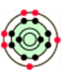
Tell how many e- are in each energy level
1st: 2nd: 3rd: 4th: 5th:
This atom has ________ valence e-
therefore it is (stable / unstable )
Write a Lewis dot diagram (Letter and dots)

- Do three things for a NEUTRAL atom with the following electron configuration:
[Ar]4s²3d¹⁰4p³

With the help of your table, write the long version of the above electron configuration.

Tell how many e- are in each energy level
1st: 2nd: 3rd: 4th: 5th:
This atom has ________ valence e-
therefore it is (stable / unstable )
Write a Lewis dot diagram (Letter and dots)

- The graph of ionization energies for a 13-electron atom is shown here. Based on the difficulty of ionization, electrons 1, 2, &3 are probably (near the nucleus / in the valence orbit)  - Based on the difficulty of ionization, electrons 12 & 13 are probably (near the nucleus / in the valence orbit)  - In the the box, draw a Bohr style atom. Your atom should have 13 protons. The electrons should be in three circular shaped orbits. | 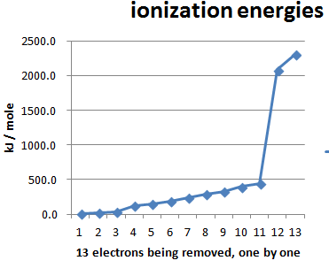 | Draw a Bohr-style atom in this box.

- Write a balanced equation for S²⁻ anion losing two electrons:
____ ____ + ____
- Write a balanced equation for the only stable calcium ion gaining two electrons:
____ + ____ ____

