1s²2s² To Lewis Dot  CλeMis+ry: http://genest.weebly.com  The first three pages are all new today. Testable on May 27, but not Quizzable May 20th! Page 4 is VERY quizzable, however. |  | Name_________  Period________

- Rewrite the following Noble Gas Abbreviations in the longer version of electron configuration (1s² 2s² etcetera)
  - [Ar]4s²3d²

  - [He]2s²2p⁵

  - Write the Lewis Dot symbol for each of the two atoms above:

- for a NEUTRAL atom with the following electron configuration:
1s²2s²2p⁶3s²3p⁶4s²3d¹⁰4p²

Draw a Bohr orbital diagram (the circles) | Write a ‘number-number-number’ diagram for this atom
 | Write a Lewis dot diagram (Letter and dots) for this atom
This atom has ________ valence e-
therefore it is (stable / unstable )

- Do three things for a NEUTRAL atom with the following electron configuration:
[Ar]4s²3d¹⁰4p³

With the help of your table, write the long version of the above electron configuration.

Tell how many e- are in each energy level
1st: 2nd: 3rd: 4th: 5th:
This atom has ________ valence e-
therefore it is (stable / unstable )
Write a Lewis dot diagram (Letter and dots)

- for a NEUTRAL atom with the following electron configuration:
1s²2s²2p⁶3s²3p⁶4s¹

Write a ‘number-number-number’ diagram for this atom | Write a Lewis dot diagram (Letter and dots) for this atom | This atom has ________ valence e-  therefore it is (stable / unstable )

- With the help of your table Rewrite the following Noble Gas Abbreviations in the longer version of electron configuration (1s² 2s² etcetera)
  - [Ar]4s²3d¹⁰4p⁴ _________________________________________________________
  - [He]2s²2p⁵ _________________________________________________________
  - Write the Lewis Dot symbol for each of the two atoms above:

- for a NEUTRAL atom with the following electron configuration:
1s²2s²2p⁶3s²3p⁶4s²3d¹⁰4p⁶5s²4d¹⁰5p³

Write a ‘number-number-number’ diagram for this atom | Write a Lewis dot diagram (Letter and dots) for this atom | This atom has ________ valence e-  therefore it is (stable / unstable )

- for a NEUTRAL atom with the following electron configuration:
1s²2s²2p⁶3s²3p⁶4s²3d⁵

Write a ‘number-number-number’ diagram for this atom | Write a Lewis dot diagram (Letter and dots) for this atom | This atom has ________ valence e-  therefore it is (stable / unstable )

- for a NEUTRAL atom with the following electron configuration:
[Ar]4s²3d²
Write a ‘number-number-number’ diagram for this atom | Write a Lewis dot diagram (Letter and dots) for this atom | This atom has ________ valence e-  therefore it is (stable / unstable )

- for a NEUTRAL atom with the following electron configuration:
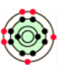
Tell how many e- are in each energy level
1st: 2nd: 3rd: 4th: 5th:
This atom has ________ valence e-
therefore it is (stable / unstable )
Write a Lewis dot diagram (Letter and dots)

- In each box, use your table from Wednesday (or online at our website) to write the name of the shape.
 | 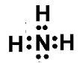 | The carbon on the left…  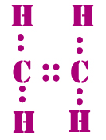
 | 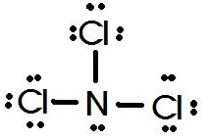 | 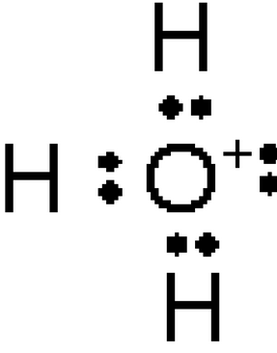

- The graph of ionization energies for a 13-electron atom is shown here. Based on the difficulty of ionization, electrons 1, 2, &3 are probably (near the nucleus / in the valence orbit)  - Based on the difficulty of ionization, electrons 12 & 13 are probably (near the nucleus / in the valence orbit)  - In the the box, draw a Bohr style atom. Your atom should have 13 protons. The electrons should be in three circular shaped orbits. | 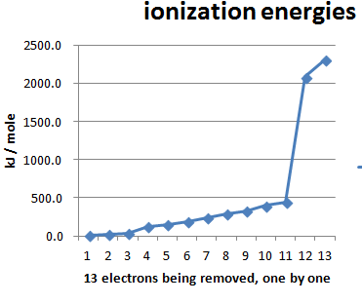 | Draw a Number-Number-Number symbol for this atom in this box.  Write the Lewis dot diagram here:

- Write a balanced equation for S²⁻ anion losing two electrons:
____ ____ + ____
- Write a balanced equation for the only stable calcium ion gaining two electrons:
____ + ____ ____

- Draw a stable Lewis Dot structure for each molecule:
H₂S | N₂
HCl | F₂

- If electrons are smiley faces, in which case is the outermost electron tougher to remove?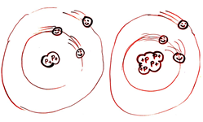

- In each pair, circle the pair that has a greater attraction.
- an electron and proton that are 2 nanometers apart or an electron and proton that are 3 nanometers apart
- an electron and the nucleus of nitrogen or an electron and the nucleus of oxygen

- In which situation below will attraction be stronger? ( A / B / no difference ) |  | - In which situation below will attraction be stronger? ( A / B / no difference )

