What Spectra tell us about electron location.  EHS Cλ3MIs+rγ - Mr. Genest | ”Che mistry” by Noor | Name_________________  Date__________________

- (Fill in the blanks by using the words low or high)
Each element produces a unique set of emission or absorption lines. An emission spectrum involves transitions of electrons from ___________ to ______________ energy states. An absorption spectrum involves transitions of electrons from _______________ to ___________ energy states. These transitions occur only between discrete energy levels, and thus the lines occur only at certain wavelengths and at no others.

- Consider just four of the energy levels in a certain atom, as shown in this diagram:
- draw arrows indicating all the possible transitions for an electron jumping up between any of the levels.[Hint: there are six possible ]
- How many different colors of light will be emitted when the electron moves down among these levels? __________
- Which transition corresponds to the highest energy light emitted?
From n = _______ to n = ________ .
- Which transition corresponds to the smallest energy light emitted?
From n = _______ to n = ________ .
- Which transition corresponds to the highest energy of heat absorbed?
From n = _______ to n = ________ .
- Which transition corresponds to the smallest energy heat absorbed?
From n = _______ to n = ________ .

- How can a hydrogen atom, which has only one electron, have so many spectral lines?

- What elements are present in the object that produced the "Spectrum of Unknown Composition"? Explain your method and relate this activity to the way astronomers use spectra to identify the composition of a star.
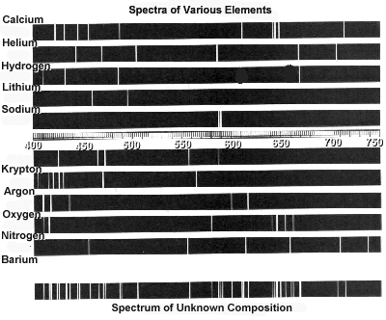
- Which of the following electron transitions in a hydrogen atom will emit a photon, which absorb
a photon? (How do you know?)

A. n = 1 to n = 3
B. n = 4 to n = 3
C. n = 3 to n = 2
D. n = 3 to n = 1
E. n = 2 to n = 3

5B. Which of the above electron transitions in a hydrogen atom will result in emission of light with
the most energy?

7. List the visible spectrum in order from lowest energy to highest energy, from memory:

____________ ____________ ____________ ____________ ____________ ____________ ____________
highest energy
lowest energy

Remember:
An electron can move from a lower to a higher energy level by absorbing a photon.
An electron can move from a higher to a lower energy level by emitting a photon.

On these diagrams, only consider the five lowest permitted orbits/energy levels in a  hydrogen atom, and that the amount of jump between levels is correlated to the energy of  the photon that is absorbed or emitted.  An electron is currently in energy level 3, as shown at right.  Clearly circle your answers below.  (a) Which electron jump starting from energy level 3 would  emit the highest-energy photon?  3→ 5  3 →4  3→ 2  3 →1  (b) Which electron jump starting from energy level 3 would  emit the lowest-energy photon?  3 →5  3 →4  3→ 2  3 →1  (c) Which electron jump starting from energy level 3 would absorb the highest-energy  photon?  3 →5  3→ 4  3→ 2  3 →1  .  (d) Which electron jump starting from energy level 3 would absorb the lowest-energy  photon?  3 →5  3 →4  3→ 2  3→ 1 | 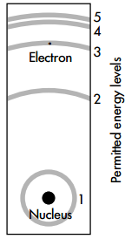

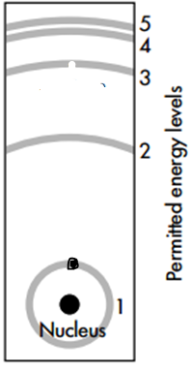 | Now consider an electron currently in the ground state (energy  level 1), as shown at right. Clearly circle your answers below.  (e) Which electron jump starting from energy level 1 would  absorb the highest-energy photon?  1→ 5  1→ 4  1→ 3  1→ 2  .  (f) Which electron jump starting from energy level 1 would  absorb the lowest-energy photon?  1→ 5  1→ 4  1 →3  1→ 2

- Explain why it is not possible for a ground state electron to emit a photon.

- What is the difference between the ground state and the excited state of electron positions?

- What does an atom do to emit a photon?

- How can the energy levels of electrons be determined by measuring the light emitted from an
atom?
- Why does electromagnetic radiation in the ultraviolet region represent a larger energy transition
than does radiation in the infrared region?
From memory, list the 3 types of radiation on the electromagnetic spectrum that are too high energy for the human eye to detect:
a. c.
b.

9. From memory, list the 3 types of radiation on the electromagnetic spectrum that are too low energy for the human eye to detect:
a. c.
b.

