How to draw electron configurations (first two types…)  CλeMis+ry: http://genest.weebly.com  Stop in for help every day at lunch and Tues, Weds., &Thurs after school!  After-hours question? Email me at home: eagenest@madison.k12.wi.us | 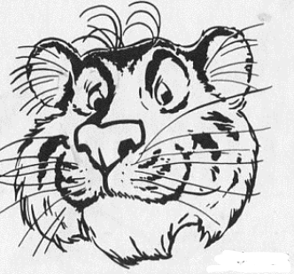 | Name_________  Period________

Assume all atoms have neutral charge unless otherwise stated.

- Name two things you can do to an atom which will cause an electron to rise to a higher orbit:

  - _____________________
  - _____________________

- What is the mass of each, (in a.m.u.s)? ________proton ________neutron ________ electron
- Which has more energy,
  - yellow light
  - green light
- Draw the dot-dash and circles electron configurations for carbon | - Draw the dot-dash and circles electron configurations for the most common ion of oxygen
- Draw the dot-dash and circles electron configurations for oxygen | - Draw the dot-dash and circles electron configurations for the lowest mass element in Group 3
- What is the charge of each, (choose 0, +1, or -1)? _____proton _____neutron _____ electron

- When an orbiting electron loses energy the atom emits a

  - photon
  - neutron
  - proton
  - nucleon

Place the following events in chronological order (1 = first, 4 = last) to describe how an electron absorbs and emits energy:
- electron absorbs energy at ground state. ______
- electron jumps to excited state. ______
- atom is energized with electricity. ______
- electron falls to ground state. ______
** Put a star by the step where light is emitted.
The next four questions all refer to the black arrows below which show three possible transitions for an electron orbiting around a nucleus
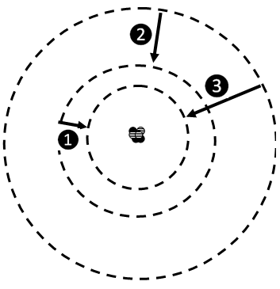
- Lines 1, 2, and 3 all represent an electron dropping down. When this happens the atom will
  - Emit a photon
  - Absorb a photon
  - Emit a proton
  - Absorb a proton

- Of these three electron movements, which is the highest energy?

  - transition❶
  - transition ❷
  - transition ❸

- If transition ❶ and transition❷ make an orange photon and a green photon, respectively, what color photon might transition ❸ make? ____________ (I will accept any reasonable answer).
- Draw one new line labeled (6) onto the bright line emission spectrum in the box to showthe position where the light caused by ❻ would appear
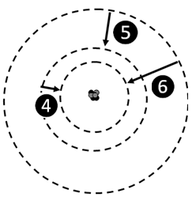 | answer here by drawing one vertical line in the correct position  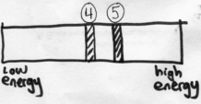

- Which of the following statements is most likely?
  - transition ④ is from the absorption of a large amount of energy and transition ⑥ is from the absorption of a small amount of energy
  - transition ④ is from the absorption of a small amount of energy and transition ⑥ is from the absorption of a large amount of energy
  - transition ④ is from the emission of a Blue photon and transition ⑥ is from the absorption of a Blue photon
  - transition ④ is from the emission of a Red photon and transition ⑥ is from the absorption of a red photon

- Mark (E)xcited state or (G)round state for each of the following electron configurations of neutral atoms.
  - _______ 0-1-0
  - _______ 1-0-0
  - _______ 2-0-0
  - _______ 0-2-0

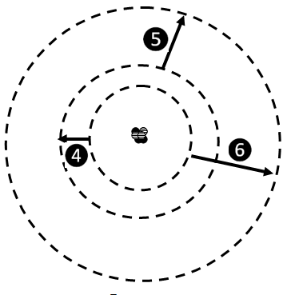
- Which of these will absorb the most energy?
  - electron transition ④
  - electron transition ⑤
  - electron transition ⑥

- Mark (E)xcited state or (G)round state for each of the following electron configurations of neutral atoms. Then write the 0-0-0 style electron configuration. (You may find it helpful to number the orbits, starting with 1 for the innermost orbit.)
- 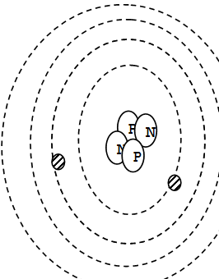 |  | - 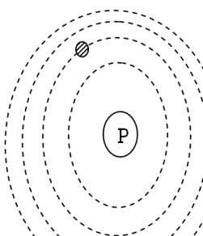 |  | - 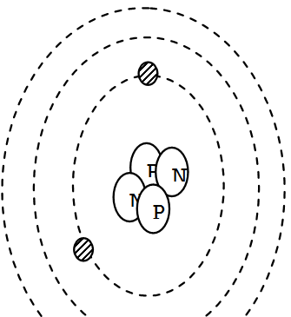

- Mark (E)xcited state or (G)round state for each of the following electron configurations of neutral atoms. Then write the 0-0-0 style electron configuration. (You may find it helpful to number the orbits, starting with 1 for the innermost orbit.)

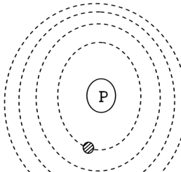 |  | - l  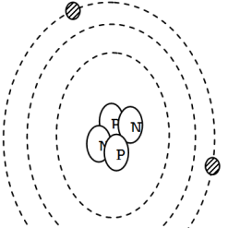 |  | - 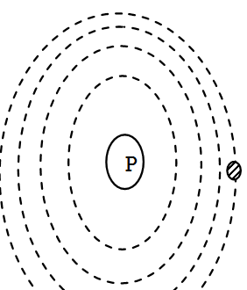

- Circle the drawing below that is usually called a “Bohr Atom” (because it was invented by Niels Bohr)

