(Answer key for the teacher to use(
Video: BBC the search for reality (video alone: 28 min) 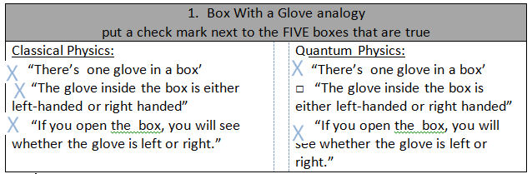
- Gedankenexperiment
What is the English translation of Gedankenexperiment ?
What was the name of Einstein’s last Gedankenexperiment ?
What equipment do you need to do a Gedankenexperiment ?
In what situations do physicists do Gedankenexperiment ?
Bohr’s view of atomic particles can be described as

Pause at 24:20
The EPR Paradox was proposed in 1935 but not tested until 1997. Why?
The EPR Test in 1997 was performed in (Geneva, actually, although I put Copenhagen on the graphic below) by Nicolas Gisin - University of Geneva (where? who?)
In the view of Copenhagen, the three boxes represent the Lab Equipment. Write a description under each. Label the 5 km distance between each box. Add a curly line to show the fiber optic tube that carried the light.
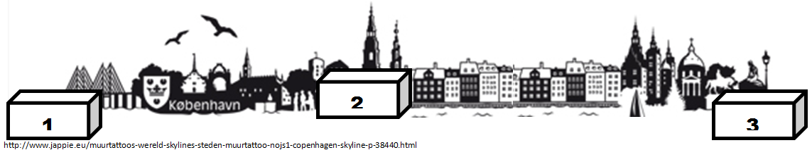
FIRST: Create one photon with a certain property. but don’t look at the property. Until you look at the property, the photon can have both ways.

SECOND: Split the photon into a smaller pair of photons with… opposite properties. Important, what you should observe at this point: nothing, you’ll ruin the experiment by forcing the particle to be something

Send the photon pairs to two cities , 10 km apart by putting them in fiber optic phone lines.

As soon as the photons arrive, do what? Observe the property.

What is this evidence of? It is evidence that two atoms can have entanglement at a quantum level. They communicate this faster than the speed of light.

4 minute quickwrite: “To be, not to be, or maybe to be.”
What does the video mean by this? THIS IS AN OPTIONAL EXIT SLIP

Guided notes. Name____________________
pause 11:43
- Box With a Glove analogy
put a check mark next to the FIVE boxes that are true
Classical Physics:  □ “There’s one glove in a box’  □ “The glove inside the box is either left-handed or right handed”  □ “If you open the box, you will see whether the glove is left or right.” |  | Quantum Physics:  □ “There’s one glove in a box’  □ “The glove inside the box is either left-handed or right handed”  □ “If you open the box, you will see whether the glove is left or right.”

- Gedankenexperiment pause 17:08
What is the English translation of Gedankenexperiment ?

What was the name of Einstein’s last Gedankenexperiment ?

What equipment do you need to do a Gedankenexperiment ?

In what situations do physicists do Gedankenexperiment ?

Bohr’s view of atomic particles can be described as

Pause at 24:20
- In the view of Copenhagen, the three boxes represent the Lab Equipment. Write a description under each. Label the 5 km distance between each box. Add a curly line to show the fiber optic tube that carried the light.

__________________
__________________
__________________

_________________
_________________
_________________

_________________
_________________
_________________

- What were the steps in Nicolas Gisin’s 1997 experiment?

FIRST: Create one photon with a certain property.

SECOND: Split the photon into a smaller pair of photons with__________

Important, what you should observe at this point:

Send the photon pairs to two cities , 10 km apart by putting them in

As soon as the photons arrive, do what?

What is this evidence of?

4 minute quickwrite: “To be, not to be, or maybe to be.”
What does the video mean by this?

4 minute quickwrite: “To be, not to be, or maybe to be.”
What does the video mean by this?

