How to draw electron configurations the third way  CλeMis+ry: http://genest.weebly.com  Stop in for help every day at lunch and Tues, Weds., &Thurs after school!  After-hours question? Email me at home: eagenest@madison.k12.wi.us | 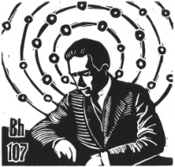 | Name_________  Period________

Assume all atoms
- For an atom with 24 electrons,
  - Fill the electron boxes
 | 1s |  |  |  | 2s |  |  |  | 2p |  |  |  |  |  |  |  | 3s |  |  |  | 3p
 | Increasing energy
 |  |  |  | 4s |  |  |  | 3d |  |  |  |  |  |  |  |  |  |  | 4p

- If one electron moves from n=2 to n=4 the atom will ( emit / absorb ) a photon

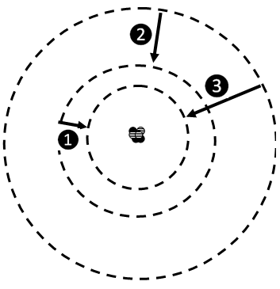
- Lines 1, 2, and 3 all represent an electron dropping down. When this happens the atom will
  - Emit a photon
  - Absorb a photon
  - Emit a proton
  - Absorb a proton

- Of these three electron movements, which is the highest energy?

  - transition❶
  - transition ❷
  - transition ❸

- If transition ❶ and transition❷ make an orange photon and a green photon, respectively, what color photon might transition ❸ make? ____________ (I will accept any reasonable answer).
- For an atom with 20 electrons,
  - Fill the electron boxes
 | 1s |  |  |  | 2s |  |  |  | 2p |  |  |  |  |  |  |  | 3s |  |  |  | 3p
 | Increasing energy
 |  |  |  | 4s |  |  |  | 3d |  |  |  |  |  |  |  |  |  |  | 4p

- For a neutral atom of oxygen [in the ground state],
  - How many electrons should it have? __________
  - Fill the electron boxes
 | 1s |  |  | 2s |  | 2p |  |  |  | 3s |  |  | 3p

- For an atom with 17 electrons,
  - Fill the electron boxes
 | 1s |  | 2s |  | 2p |  |  |  | 3s |  |  | 3p

- For an atom with 7 electrons,
  - Fill the electron boxes
 | 1s |  | 2s |  | 2p |  |  |  | 3s |  |  | 3p

