How to draw boxes and arrows for larger atoms  CλeMis+ry: http://genest.weebly.com  Stop in for help every day at lunch and Tues, Weds., &Thurs after school!  After-hours question? Email me at home: eagenest@madison.k12.wi.us | 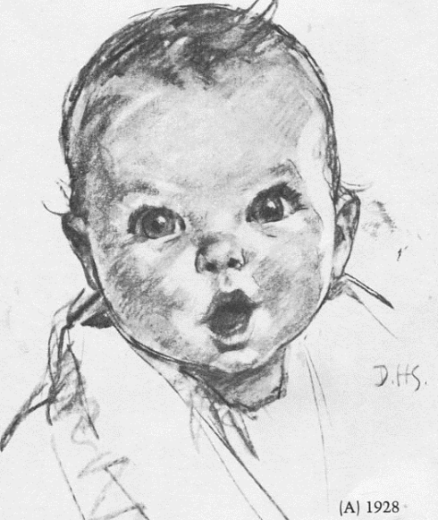 | Name_________  Period________
- From memory, write your ‘pine tree’ mnemonic device, without looking at your notes:

- Write the boxes and arrows configuration and the modern shorthand configuration (1s² 2s² 2p⁶ etc) for each:
  - strontium (atomic # 38)
Boxes and arrows: | Shorthand:
  - zinc (atomic # 30)
Boxes and arrows: | Shorthand:

  - helium (atomic # = 2)
Boxes and arrows: | Shorthand:

  - zirconium (atomic # = 40)
Boxes and arrows: | Shorthand:

- Place the following events in chronological order (1 = first, 4 = last) to describe how an electron absorbs and emits energy:
- electron absorbs energy at ground state. ______
- electron jumps to excited state. ______
- atom is energized with electricity. ______
- electron falls to ground state. ______
** Put a star by the step where light is emitted.

- Write the electron shorthand configuration (like 1s²2s², etc)) for an atom of neutral phosphourous

- What element is this? _________________
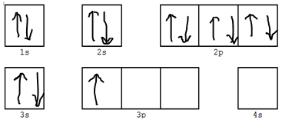

- For 1s²2s²2p⁶3s²3p⁶4s²3d¹⁰4p²
  - how many electrons are in each shell
  - what element is this?
- How many e- are in the valence shell of
1s²2s²2p⁶3s²3p⁶4s²3d¹⁰4p⁶5s²4d¹⁰5p¹
- For 1s²2s²2p⁶3s¹
  - how many electrons are in each shell
  - what element is this?

