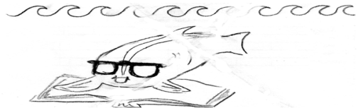 |  | Guid  ed  Read  ing : Quantum Theory | Name___________________  Date____________________
Hand in at the bell. These will serve as notes to study for Friday's test. I will give it back promptly tomorrow. Use the Wilbraham Textbook pp. 363 – 365 Make it so the teacher can read it.
Pencil or pen are both okay, drawings are as legitimate as good as words. Colors are nice too.
Paragraph 1 (Starts with “A quantum of energy...)
Paragraph 2 (Starts with “tHE AMOUNT OF ENERGY...)
Paragraph 3 (Starts with “iN 1926, THE ..)
Paragraph 4 (Starts with “Like the Bohr model..)

Paragraph 5 (Starts with “In the quantum...)
Paragraph 6 (Starts with “As in the Bohr...)
Paragraph 7 (Starts with “Within each principal...)
Paragraph 8 (Starts with “Where are the...)

Extra Credit (do this on separate paper; it won't be checked until tomorrow): Sketch the four atomic models from page 362. Label them with names and what each piece is. Copy the Sentence under each. No credit given for squeezing it onto this sheet.

