Review (1 of 2 )  EHS Cλ3MIs+rγ  Mr. Genest | 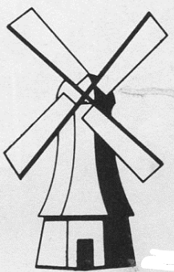 | Name_________________  Date__________________

- How many elements are there in Group 1?
- Which element in Period 4 has the largest radius?

- For a neutral atom of fluorine [in the ground state],
  - How many electrons should it have? __________
- write the boxes and arrows electron diagram | - write the shorthand abbreviation of the electron diagram
- write a Bohr circle and nucleus diagram | - write the shorthand for the Bohr diagram

- For a neutral atom of magnesium [in the ground state],
  - How many electrons should it have? __________
- write the boxes and arrows electron diagram | - write the shorthand abbreviation of the electron diagram
- write a Bohr circle and nucleus diagram | - write the shorthand for the Bohr diagram

- For the second element in Period 6,
  - The name of this element is _________________
  - If this neutral element lost electrons it would become ( positive / negative ).
  - Predict the oxidation state of this element after it forms its ion ________
- When neutral ${}_{16}^{33}S$ changes into an ion, it will be a ( cation / anion ) with a charge of ______.
- ${}_{16}^{33}S$ has _______ protons _______ electrons _______ neutrons
- the ion version of the above atom has _______ protons _______ electrons _______ neutrons
- Write the electron configuration (letters and numbers, starting with 1s² 2s²…, , no boxes and arrows) for a Ca²⁺ ion
- Which element in Period 4 is the easiest to steal an e- from?

- Circle one or more elements that would be expected to have very similar properties to oxygen:
Nitrogen Osmium Sulfur Fluorine

- In each blank write <, =, or > to describe the amount of electrons in the two things:
- a neutral sodium atom ________ a sodium ion
- a Sr atom ________ a Sr²⁺ ion

- Which one of these series of drops would most likely give off only infrared light?  Lyman / Balmer / Paschen  - Which one of these series of drops would most likely give off only visible light?  Lyman / Balmer / Paschen  - Which one of these series of electron drops would most likely give off only ultraviolet light?  Lyman / Balmer / Paschen  - These series of energy transitions are named for their discoverers. Which emission series was probably the most dangerous to be viewing without eye protection?  Paschen Balmer Lyman | 