Review (2 of 2 )  EHS Cλ3MIs+rγ  Mr. Genest |  | Name_________________  Date__________________

- Which are quantized?
- (yes/no )A click shifter on a ten speed bike  - (yes/no )Electron energy in hydrogen  - (yes/no )Electron energy in gold atoms | - (yes/no )the mass of something made of atoms  - (yes/no )The venetian blinds in our classroom  - (yes/no )The volume on an iPod | - (yes/no )The second hand on the clock in our classroom  - (yes/no )The rotation of a doorknob  - (yes/no )The altitude of the steps on a stairway

- Are these four shapes associated more with Niels Bohr or the modern theory of e- from Schrodinger et al?  - Compared to each of these shapes, where is an e- located? (circle one or more choices)  - inside them  - on the surface of them  - outside them  - Answer in a sentence. What does the number 90% have to do with these drawings? | 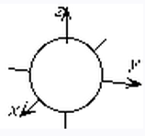 | 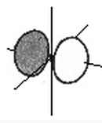
 | 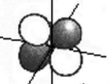 | 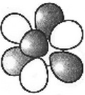

- Complete the chart.
p | n | e | symbol | atomic number | mass number | charge
5 |  |  |  |  | 12 | 0
 | 18 | 18 |  | 17
13 |  | 10 |  |  | 28
 | 21 | 18 |  | 20 |  | +2
16 | 16 | 18

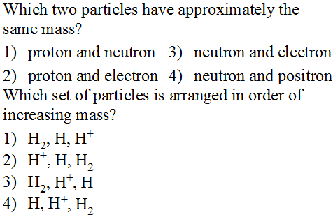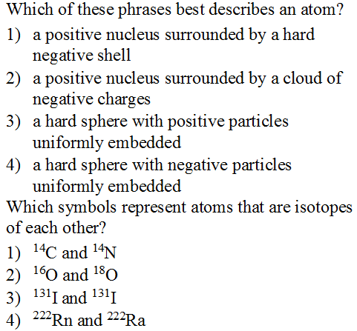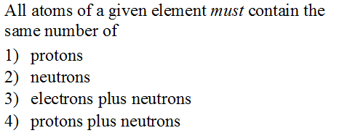

- Which scientist is most associated with this style of drawing an atom?  - Niels Bohr  - Erwin Schrodinger  - Is the drawing of this chlorine atom showing orbitals or orbits? (circle one)  - If these circles were the only places an electron could be, how many different wavelengths of light could this atom emit?  - Thirty five wavelengths  - Seventeen wavelengths  - Seven wavelengths  - Three wavelengths | - 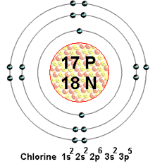

- According to the electromagnetic spectrum you memorized, which has more energy? (circle one) green light or microwaves

- For a neutral atom of Niobium (atomic # 41) [in the ground state],
  - How many electrons should it have? __________
- write the boxes and arrows electron diagram | - write the shorthand abbreviation of the electron diagram
- write a Bohr circle and nucleus diagram | - write the shorthand for the Bohr diagram

