Bonds Between Non-metal Atoms  EHS Cλ3MIs+rγ  Mr. Genest |  | Name_________________  Date__________________

- How many valence e- are in an atom that is 1s²2s¹2p¹?

- Which electrons are usually involved in forming a bond between two nonmetal atoms?

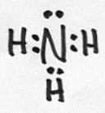 | - For the molecule shown here,  - What is the formula of the substance? (e.g. the formula of water would be written H₂O)  - how many bonds does it have?  - altogether, how many e- are in bonds?  - altogether, how many e- are nonbonding?  - how many valence e- altogether?

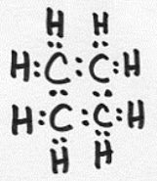 | - For the molecule shown here,  - What is the formula of the substance? (e.g. the formula of water would be written H₂O)  - how many bonds does it have?  - altogether, how many e- are in bonds?  - altogether, how many e- are nonbonding?  - how many valence e- altogether?

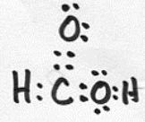 | - For the molecule shown here,  - What is the formula of the substance? (e.g. the formula of water would be written H₂O)  - how many bonds does it have?  - altogether, how many e- are in bonds?  - altogether, how many e- are nonbonding?  - how many valence e- altogether?

- Where in an atom are valence e- found?

- How many valence e- are in an atom with e- configuration of 1s²2s¹?

- In this box, try to draw a smaller amount of glass than was in our notes today (make it have about two Silicon atoms and an appropriate amount of other atoms. Be brave; we will accept any reasonable attempt!)
  - In your drawing, label one of the bonding electrons
  - Label one of the nonbonding electrons.

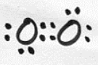 | - For the molecule shown here,  - What is the formula of the substance? (e.g. the formula of water would be written H₂O)  - how many bonds does it have?  - altogether, how many e- are in bonds?  - altogether, how many e- are nonbonding?  - how many valence e- altogether?

- Make a guess what you think the electron structure of hydrogen peroxide might look like. The formula of hydrogen peroxide is HOOH. You may base it on the structure that you already know for water in the previous problem.

- Translate the Lewis dot structure into a line structure |  |  | - Translate the line structure into a Lewis dot structure
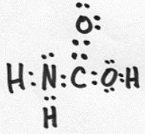 |  |  | 