Bonds  EHS Cλ3MIs+rγ  Mr. Genest | 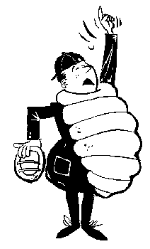 | Name_________________  Date__________________

- How many valence e- are in an atom that is 1s²2s¹2p⁵?
- What two types of elements will combine to form a

  - ionic bond?

  - metallic bond?

  - covalent bond?

- Atoms are stable when they have either an octet of e- (eight e- around most elements) or a duet of e- (two e- around beryllium, lithium, hydrogen, helium). draw a circle around each stable atom. If you find an unstable atom, write UNSTABLE next to it.
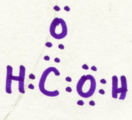 | 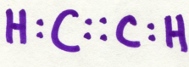 | 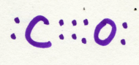

- Convert these dot-drawings to line-shorthand drawings.

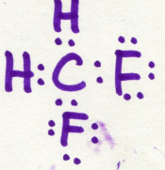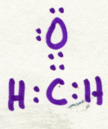

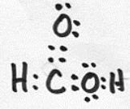 | - For the molecule shown here,  - What is the formula of the substance? (e.g. the formula of water would be written H₂O)  - how many bonds does it have?  - altogether, how many e- are in bonds?  - altogether, how many e- are nonbonding?  - how many valence e- altogether?

- Why do the electrons hold together atoms in a
  - ionic bond?

  - metallic bond?

  - covalent bond?

- 1s²2s²2p⁶3s²3p⁶4s²3d⁹ has ____ valence e- . Its dot symbol is…

- Draw the electron dot symbol for a neutral atom of each:
  - calcium

  - chlorine

- (Circle one) Ionic bonds are usually formed when nonmetals react with (metals/nonmetals)
- (Circle one) Covalent bonds are usually formed when nonmetals react with (metals/nonmetals)
- (Circle one) Metallic bonds are usually formed when metals react with (metals/nonmetals)
- Atoms are stable when they have either an octet of e- (eight e- around most elements) or a duet of e- (two e- around beryllium, lithium, hydrogen, helium). draw a circle around each stable atom. If you find an unstable atom, write UNSTABLE next to it.
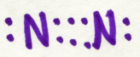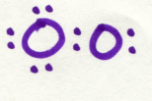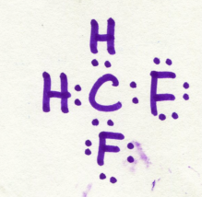

- Convert these dot-drawings to line-shorthand drawings.

