dipole molecules  CλeMis+ry: http://genest.weebly.com  Stop in for help every day at lunch and Tues, Wed., &Thurs after school!  After-hours question? Email me at home: eagenest@madison.k12.wi.us |  | Name_________  Period________

- Which element in PERIOD 3 has the least electronnegativity?

- Determine whether each molecule is a dipole by doing the following steps:
  - look up the electronegativity number on your chart from Thursday. Write this number next to each atom in your molecule (this step is optional)
  - draw an arrow to show the dirction of polarity of each bond.
  - draw a hollow arrow to show the overall polarity of the molecule OR write nonpolar molecule below the molecule
- (Circle one) Ionic bonds are usually formed when nonmetals react with (metals/nonmetals)
- (Circle one) Covalent bonds are usually formed when nonmetals react with (metals/nonmetals)
- (Circle one) Metallic bonds are usually formed when metals react with (metals/nonmetals)

- draw a cloud that is either symmetrical, lopsided, or really lopsided, with the fattest part of the cloud going towards the more electronegative element.
Draw an arrow, parallel to the bond, that shows the direction where the e- density is greatest. The first has been done as an example.
- Li-S  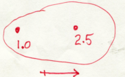 | - O - C | - C-C
- Determine whether each molecule is a dipole by doing the following steps:
  - look up the electronegativity number on your chart from Thursday. Write this number next to each atom in your molecule (this step is optional)
  - draw an arrow to show the dirction of polarity of each bond.
  - draw a hollow arrow to show the overall polarity of the molecule OR write nonpolar molecule below the molecule

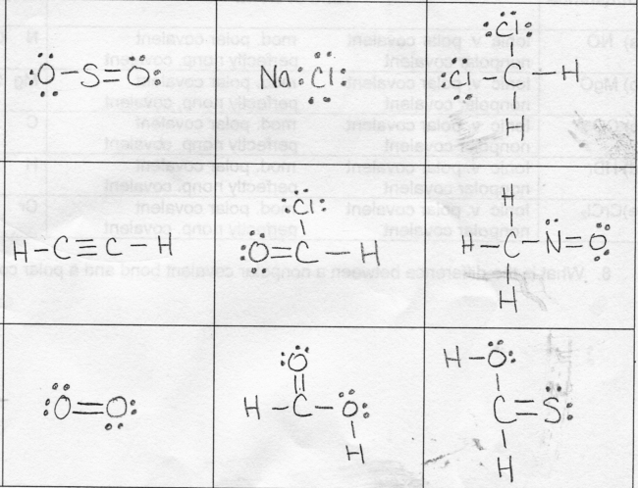

warmup to glue into notes
Purpose ____________________________________________________________________________

Warmup: 