dipole- dipole IMF  CλeMis+ry: http://genest.weebly.com  Stop in for help every day at lunch and Tues, Wed., &Thurs after school!  After-hours question? Email me at home: eagenest@madison.k12.wi.us | 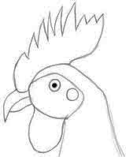 | Name_________  Period________

- How many molecules are here? ______
- How many molecules here have a + end AND a - end _______
- How many molecules here are cations (just purely +): _______
- How many molecules here are anions (just purely -): _______
- How many of these are “dipoles”? ______
- Draw little dashed lines on the picture to connect things that feel attracted to each other.

- How many molecules are here? ______
- How many molecules here have a + end AND a - end _______
- How many molecules here are cations (just purely +): _______
- How many molecules here are anions (just purely -): _______
- How many of these are “dipoles”? ______
- Draw little dashed lines on the picture to connect things that feel attracted to each other.

- Extend this picture by adding five more molecules that look identical to the nine molecules already here. Important: make them point in the correct direction which their attraction causes. | 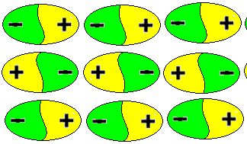

- Define IMF:

________________________________________________________________
- Write the electronegativity number next to each atom.  - This atom has _____ covalent bonds  - Of these, ______ are polar covalent bonds  - And _____ are nonpolar covalent bonds |  | Write arrows next to each bond to show which end of the bond the electrons go more towards  Does this molecule have a negative end and positive end that are opposite to each other?  (yes/no)  If you answered “yes”, draw a hollow arrow which shows which end the negative electrons are mostly going towards.  This molecule is  (polar / nonpolar )
- Write the electronegativity number next to each atom.  - This atom has _____ covalent bonds  - Of these, ______ are polar covalent bonds  - And _____ are nonpolar covalent bonds | 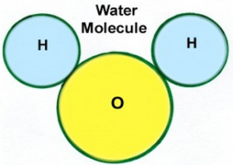 | Write arrows next to each bond to show which end of the bond the electrons go more towards  Does this molecule have a negative end and positive end that are opposite to each other?  (yes/no)  If you answered “yes”, draw a hollow arrow which shows which end the negative electrons are mostly going towards.  This molecule is  (polar / nonpolar )
- Write the electronegativity number next to each atom.  - This atom has _____ covalent bonds  - Of these, ______ are polar covalent bonds  - And _____ are nonpolar covalent bonds |  | Write arrows next to each bond to show which end of the bond the electrons go more towards  Does this molecule have a negative end and positive end that are opposite to each other?  (yes/no)  If you answered “yes”, draw a hollow arrow which shows which end the negative electrons are mostly going towards.  This molecule is  (polar / nonpolar )

