all three types of IMF  CλeMis+ry: http://genest.weebly.com  Stop in for help every day at lunch and Tues, Wed., &Thurs after school!  After-hours question? Email me at home: eagenest@madison.k12.wi.us |  | Name_________  Period________

- Draw small arrows next to each bond to show the polartity of the bond. Draw a large hollow arrow to show the polarity of the molecule.
If the molecules in the first square are correctly oriented, write CORRECT in the empty square. Otherwise, redraw the molecules in the second square.
- Match the type of intermolecular force with the correct definition:
- ____ van der Waals force  - ____ Dipole Interactions  - ____ Hydrogen Bonding | - the strongest type of intermolecular force  - the weakest intermolecular force  - the medium strength intermolecular force

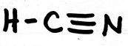 |  | 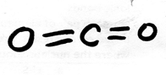 |  | 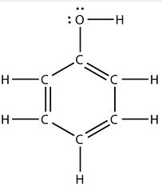
What is the strongest IMF present in this molecule?  □ just van der Waals  □ dipole  □ hydrogen bonding |  | What is the strongest IMF present in this molecule?  □ just van der Waals  □ dipole  □ hydrogen bonding |  | What is the strongest IMF present in this molecule?  □ just van der Waals  □ dipole  □ hydrogen bonding
How can you tell? |  | How can you tell? |  | How can you tell?
How sticky is this molecule?  □ barely sticky  □ normal stickiness  □ very sticky |  | How sticky is this molecule?  □ barely sticky  □ normal stickiness  □ very sticky |  | How sticky is this molecule?  □ barely sticky  □ normal stickiness  □ very sticky

- Write the electronegativity number next to each atom.  - This atom has _____ covalent bonds  - Of these, ______ are polar covalent bonds  - And _____ are nonpolar covalent bonds | 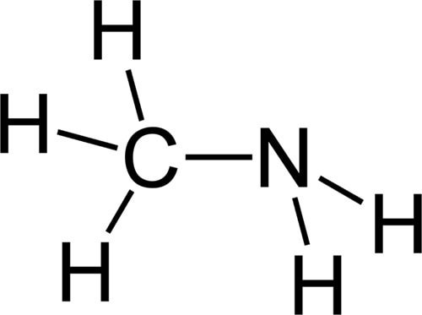 | - Write arrows next to each bond to show which end of the bond the electrons go more towards  - Draw a hollow arrow which shows which end the negative electrons are mostly going towards.  - This molecule is  (polar / nonpolar )

- Match the type of intermolecular force with the correct definition:
- ____ van der Waals force  - ____ Dipole Interactions  - ____ Hydrogen Bonding | - occurs in all molecules, even between nonpolar molecules  - cannot occur unless a molecule contains fluorine, nitrogen, or oxygen  - occurs in all molecules that have regions of (+) AND (-) charge

 |  | Nitrogen, the kind you’re breathing now. |  | 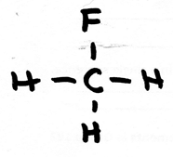
What is the strongest IMF present in this molecule?  □ just van der Waals  □ dipole  □ hydrogen bonding |  | What is the strongest IMF present in this molecule?  □ just van der Waals  □ dipole  □ hydrogen bonding |  | What is the strongest IMF present in this molecule?  □ just van der Waals  □ dipole  □ hydrogen bonding
How sticky is this molecule?  □ barely sticky  □ normal stickiness  □ very sticky |  | How sticky is this molecule?  □ barely sticky  □ normal stickiness  □ very sticky |  | How sticky is this molecule?  □ barely sticky  □ normal stickiness  □ very sticky

- Write the electronegativity number next to each atom.  - This atom has _____ covalent bonds  - Of these, ______ are polar covalent bonds  - And _____ are nonpolar covalent bonds | this is the disinfectant Phenol | - Write arrows next to each bond to show which end of the bond the electrons go more towards  - Draw a hollow arrow which shows which end the negative electrons are mostly going towards.  - This molecule is  (polar / nonpolar )

Name_______________________________ |  | Solve any 5 problems for full credit. Solve more for extra credit.
Review Sheet (2 of 5) for the June 2014 Chemistry Final Exam
(The exam covers only second semester, from Jan 27 to June 6th)

Disclaimer: Studying this packet is a great start but is not a substitute for actually studying all 80 days of material. Hopefully time spent with this packet will help you find what parts of the semester you need to go back and study in depth, either from your notes or from http://genest.weebly.com
VOCABULARY | allotrope  atmospheric pressure  barometer  boiling point  energy  heating curve (sometimes called a cooling curve)  kinetic energy  kinetic molecular theory  melting point  pascal (a unit, abbreviated Pa)  phase diagram  a unit abbreviated atm  triple point  vacuum  vapor  vapor pressure

- Write the standard pressure in ________ kPa ________ mmHg

Using the chart at right, answer each:
- If diethyl ether in this room had a vapor pressure of 600 mmHg would it be boiling?

- How high must the vapor pressure of a substance be at East High School for that substance to boil?

- Will the boiling point of a substance be higher on top of a mountain or in Madison?

- Fill in the empty boxes using the vapor pressure from the graph above.
substance | vapor pressure | the ambient pressure | Is the substance boiling? | temperature
ethyl alcohol |  | 500 mmHg | yes
diethyl ether | 400mmHg | 400 mmHg | yes
 | 600 mmHg | 760 mmHg | no | 74 °C
water | 200 mmHg |  | yes | 64 °C
- Draw your own heating curve for aluminum, knowing that it melts at 660 °C and vaporizes at 2467 °C Label the x-axis time and label the y-axis temperature.

- The temperature at which all motion stops is ________ K or __________°C

- Show the work need to convert 50 mm Hg to kPa.

- The graph below is a phase diagram for substance. Label the following parts on the graph: sublimation line, normal boiling point, vapor/gas, liquid, solid, triple point, and critical point. | 