rank these by their forces  CλeMis+ry: http://genest.weebly.com  Stop in for help every day at lunch and Tues, Wed., &Thurs after school!  After-hours question? Email me at home: eagenest@madison.k12.wi.us | 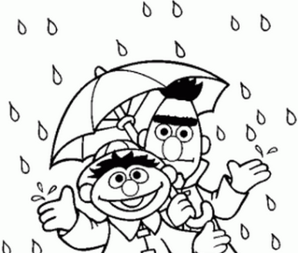 | Name_________  Period________

- Draw small arrows next to each bond to show the polartity of the bond.
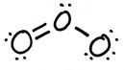 |  | 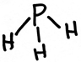 |  | 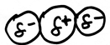
What is the strongest IMF present in this molecule?  □ just van der Waals  □ dipole  □ hydrogen bonding |  | What is the strongest IMF present in this molecule?  □ just van der Waals  □ dipole  □ hydrogen bonding |  | What is the strongest IMF present in this molecule?  □ just van der Waals  □ dipole  □ hydrogen bonding

- Match the type of intermolecular force with the correct definition:
- ____ van der Waals force  - ____ Dipole Interactions  - ____ Hydrogen Bonding | - the strongest type of intermolecular force  - the medium strength intermolecular force  - the weakest intermolecular force

FIRST, CIRCLE THE MOLECULE WITH STRONGER IMF.
Then, answer the following questions by drawing a <, = , or > symbol.

- Which would feel stickier?
______

- Compare which is stickier
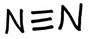 | ______ | 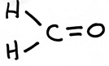

- Compare: which will boil at a lower temperature?
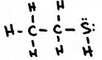 | ______ | 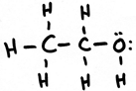

- Compare: which will freeze at a higher temperature?
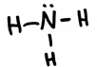 | ______ | 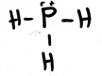

- Compare: if these are at the same temperature, which will have greater vapor pressure?
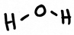 | ______

- Compare: which has greater viscosity
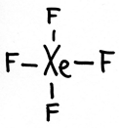 | ______ | 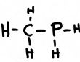

- Compare: which will boil at a lower temperature?
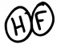 | ______ | 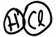

- Compare: which will freeze at a higher temperature?
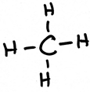 | ______ | 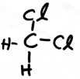

- Compare: if these are at the same temperature, which will have greater vapor pressure?
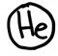 | ______ | 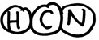

- Match the type of intermolecular force with the correct definition:
- ____ van der Waals force  - ____ Dipole Interactions  - ____ Hydrogen Bonding | - occurs in all molecules that have regions of (+) AND (-) charge  - occurs in all molecules, even between nonpolar molecules  - cannot occur unless a molecule contains fluorine, nitrogen, or oxygen

Name_______________________________ |  | Solve any 5 problems for full credit. Solve more for extra credit.
Review Sheet (3 of 5) for the June 2014 Chemistry Final Exam
(The exam covers only second semester, from Jan 27 to June 6th)

Disclaimer: Studying this packet is a great start but is not a substitute for actually studying all 80 days of material. Hopefully time spent with this packet will help you find what parts of the semester you need to go back and study in depth, either from your notes or from http://genest.weebly.com

This material appears on the website and in your notes starting around February 28.

- If you know the reaction AND you already know the ΔH…
- Do a railroad tracks style unit conversion
- You might need to convert grams to moles using the periodic table.
- For examples of this type of problem look on pages 304-306

- If you know the reaction but you need to find the ΔH … |  |  |  | - If hot water or another hot substance is gaining or losing heat and you know three of the four values for q, m, C, or ΔT
- Write a balanced reaction  - Look up the energies of each substance using a table of Standard Heat of Formation.  - Plug the table numbers into the following equation  ΔH = (ΔH of the products formation) – (ΔH of the reactants formation)  - Remember to multiply each energy by its coefficient in the balanced reaction. Be careful of all the double negative signs. To be safe, punch your answer into the calculator more than once to avoid careless goofs. |  |  |  | - Use your data to complete the equation q = m C ΔT  - For calculating metal dropped into water you should do one entire formula where all the letters are data for the water. Then do one entire formula where all the letters are data for the metal.
Use Method 1, from the grey box above.
For the reaction of  CaCl₂ + Na₂CO₃ CaCO₃ + 2NaCl ΔH = -360 kJ  3. Find how much heat is released when 9.2 moles of CaCl₂ react. | 4. Find how much heat is released when 100. grams of CaCl₂ react

Use Method 2, from the grey box above. Use the table below.
Use Method 3, from the grey box above.
Calculate the heat gained by the water.

For each change, circle either exothermic or endothermic. In each case, the system is underlined.
- You get into a parked car on July 10th and you sit on the hot car seat. (exothermic / endothermic )
- The oil in a bowl of burning oil (exothermic / endothermic )
