dissolving, mixing, per IMF  CλeMis+ry: http://genest.weebly.com  Stop in for help every day at lunch and Tues, Wed., &Thurs after school!  After-hours question? Email me at home: eagenest@madison.k12.wi.us | (flying spaghetti monster here) | Name_________  Period________
- In each trio, two of these substances would freely dissolve in each other. Circle them and cross out the substance that won’t dissolve in the other two.
a.
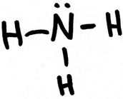 |  | 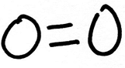 |  | 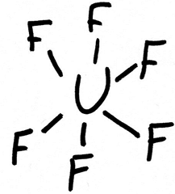

b.
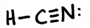 |  | 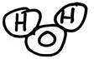 |  | 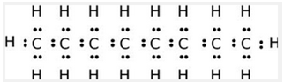

c.
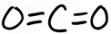 |  | 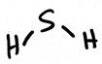 |  | 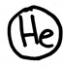

- Apply the concept of “opposite charges attract, same charges repel”.
If the molecules in the first box are pointing correctly, with opposite charges facing each other, simply write “CORRECT” in the second box
But if the molecules are pointing incorrectly, redraw them in the second box facing in correct orientation.
a.
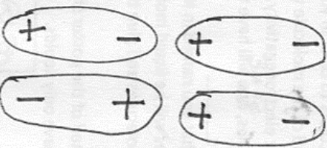

b.
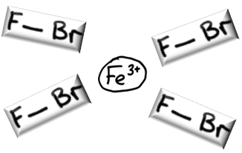

c.
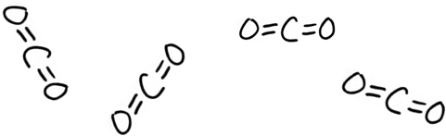

- Compare: the temperature at which these melt:
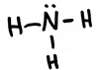 | ______ | 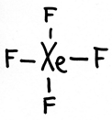

- Compare how fast each will evaporate:
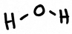 | ______ | 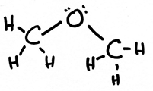

- Hydrogen bonding is extremely important in living things. The top picture shows two pieces of protein not connected, the bottom shows them connected by hydrogen bonds.
With your knowledge of what hydrogen bonding is, which of the circled bonds on the bottom is not a hydrogen bond?
( W / X / Y / Z )
