Bronsted Lowry Definiton of Acids  CλeMis+ry: http://genest.weebly.com  Stop in for help every day at lunch and Tues,&Thurs after school! | B | Name_________  Period________

Write the definition of each:
- Arrhenius Acid
- Arrhenius Base
- Bronsted Acid
- Bronsted Base

Mark each as (1) acid only (2) base only (3) both acid and base (4) true for pure water (5) none of these choices is true
- _____ has lots of OH- , less H₃O+
- _____ has no ions
- _____ is considered an electrolyte
- _____ H₂SO₄
- _____ can turn indicator paper various colors
- _____ turns phenolphthalein pink
- _____ tastes bitter
- _____ feels slippery on skin
- Write the reaction showing the ionization of water to produce two ions. Remember to show a + or – on any ions.
______ + ______ ______ + ______

- Write the reaction showing the reaction of hydroxide with hydronium to produce two water molecules. Remember to show a “+” or “– “ on any ions.
______ + ______ ______ + ______

- What happens to the hydroxide concentration in water when acid is added?
( it rises / it falls / it doesn’t change )
- What happens to the hydronium concentration in water when acid is added?
( it rises / it falls / it doesn’t change )
- What happens to the hydroxide concentration in water when base is added?
( it rises / it falls / it doesn’t change )
- What happens to the hydronium concentration in water when base is added?
( it rises / it falls / it doesn’t change )

- The following substances act as Bronsted acids in water. Write a chemical equation for each that illustrates its reaction with water.
ammonium ion, NH₄+ | ________________________ ____________________
H₃PO₄ | ________________________ ____________________
HBr | ________________________ ____________________

- The following substances act as Bronsted bases in water. Write a chemical equation for each that illustrates its reaction with water.
CHOO– | ________________________ ____________________
hydride ion: H- | ________________________ ____________________
ammonia NH₃ | ________________________ ____________________

class notes

In the each case below, redraw the molecules of the aqueous solution in the first box into the second box with the following changes:
- add ten HOH water molecules.
- show each ion or molecule as its formula, not as a circle.
- draw charges on anything that is an ion
- answer the first two questions in the third box
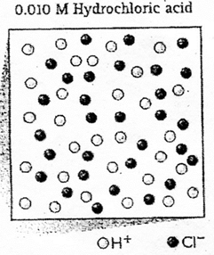 |  | - which are there more of?  ( ions / neutral molecules )  - which ion is there more of?  ( OH- / H₃O+ / H+)  - turns indicator paper which color?  ( blue / red )  - pH is ( <7 / 7 / >7 )  - conducts electricity? ( yes / no )

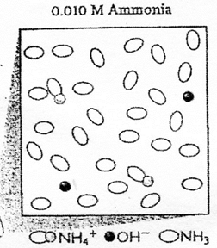 |  | - which are there more of?  ( ions / neutral molecules )  - which ion is there more of?  ( OH- / H₃O+ / H+)  - turns indicator paper which color?  ( blue / red )  - pH is ( <7 / 7 / >7 )  - conducts electricity? ( yes / no )

class notes

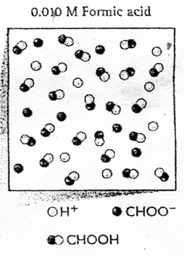 |  | - which are there more of?  ( ions / neutral molecules )  - which ion is there more of?  ( OH- / H₃O+ / H+)  - turns indicator paper which color?  ( blue / red )  - pH is ( <7 / 7 / >7 )  - conducts electricity? ( yes / no )

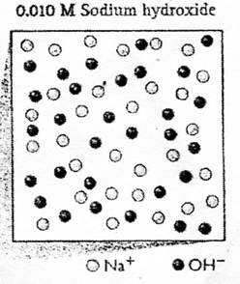 |  | - which are there more of?  ( ions / neutral molecules )  - which ion is there more of?  ( OH- / H₃O+ / H+)  - turns indicator paper which color?  ( blue / red )  - pH is ( <7 / 7 / >7 )  - conducts electricity? ( yes / no )

finish and get a stamp

