Acid #2  CλeMis+ry: http://genest.weebly.com  Start making a one sided, hand-written cheat sheet for the final exam.  See tips on the class website: http;//genest.weebly.com | 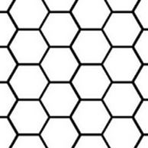 | Name_________  Period________

- Circle three substances that could make phenolphthalein turn pink (helpful table on page. 2)
NH_{3(aq)} KOH_{(aq)} CH_{4(aq)} H₂CO_{3(aq)} HCH₃COO_{(aq)} CH₃OH_{(aq)} Ba(OH)_{2(aq)} HNO_{3(aq)}
- Circle three things that could make methyl orange turn red:
NH_{3(aq)} KOH_{(aq)} CH_{4(aq)} H₂CO_{3(aq)} HCH₃COO_{(aq)} CH₃OH_{(aq)} Ba(OH)_{2(aq)} HNO_{3(aq)}

take these and write them under the four lists at left.
O²⁻ | Ca(OH)₂ | CH₄ | Li⁺
Na⁺ | HBr | Ca²⁺ | SOH
NaOH | CH₃OH | CO₃²⁻ | H₂CO₃
HNO₃ | C₂H₅OH | I₂ | Br⁻
- Take things from the box at the right and write them onto the correct lists below. You should end up with 3 things per list.
cations anions acids bases

Chemists around 1920 proposed a theory:
An acid is anything that donates a proton to another species.
A base is anything that accepts a proton from another species.

- In each case below for any substance on the LEFT side of the arrow, mark it as follows: write “base” under anything that is acting as a Bronsted-Lowry Base and write “acid” under anything that is acting as a Bronsted-Lowry Acid.
  - HSO₄⁻ + H₂O --> SO₄²⁻ + H₃O⁺
  - H₂O + NH₃ OH⁻ NH₄⁺
  - H₃PO₄ + NH₃ NH₄⁺ + H₂PO₄⁻
  - H₂PO₄⁻ + H₂O HPO₄²⁻ H₃O⁺
- What color is phenolphthalein in very basic solution?
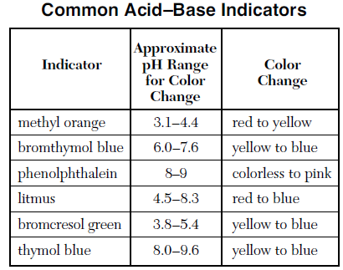
- (choose only one letter )A sample of a solution with a pH of 10 is tested separately with phenolphthalein and litmus indicator. The colors of the indicators are as follows
  - litmus is blue; phenolphthalein is pink
  - litmus is red; phenolphthalein is pink
  - litmus is blue; phenolphthalein is colorless
  - litmus is red; phenolphthalein is colorless

- What color is phenolphtalein in a beaker full of concentrated H₂SO₄?

- An indicator was used to test a water solution with a pH of 12. Of the combinations below, what is the only one that could possibly be observed in this situation?
- colorless phenolphthalin
- red litmus
- colorless litmus
- pink phenolphthalein
- A blue solution containing an acid-base indicator was tested with a pH meter and found to have a pH of 5.5. Which of the indicators shown on the table shown here could be this indicator?

- A solution was yellow in bromthymol blue and blue in bromcresol green. According to the table here, what could be the pH of this solution?

- Acid was added to a solution containing an indicator until the solution turned from blue to yellow. Which of the following would be the most acidic?
- a yellow solution containing bromthymol blue
- a yellow solution containing bromcresol green
- a yellow solution containing thymol blue
- If a beaker contains 0.00000593 moles of H+ ions, in 30.0 mL of water,
- What is the [H+]?

- what is the pH?

- If during a titration a student finds that 466 mL of HNO3 acid contains 0.00033 moles of H+
- What is the [H+]?

- what is the pH?

- If a beaker contains 4.89x10¹⁴ H+ ions, in 0.790 liters of water,
- What is the [H+]?

- what is the pH?

- find the number of H+ ions that would be in a 690.mL (units!) volume of a solution that had the same molarity you found in answer A.

- In each case below for any substance on the LEFT side of the arrow, mark it as follows: write “base” under anything that is acting as a Bronsted-Lowry Base and write “acid” under anything that is acting as a Bronsted-Lowry Acid.
- SO₄²⁻ + H₃O⁺ HSO₄⁻ + H₂O

- NH₄⁺ + H₂PO₄⁻ H₃PO₄ + NH₃

- Fill in the chart using the rule: [H+] multiplied by [OH-] equals 1x10⁻¹⁴
Test tube | concentration of hydronium (mol/L) | concentration of hydroxide (mol/L)
A | 1 x 10⁻²
B | 1 x 10⁻⁹
C |  | 1 x 10⁻⁸
D | 1 x 10⁻¹¹
E |  | 1 x 10⁻¹¹

- Fill in the chart using the rule: pH = - log[H+]

Test tube | [H+] | pH
F | 5.77 x 10⁻⁶
G | 1 x 10⁻⁵
H |  | 8
i |  | 3.8

