Conjugate Acids and Bases  CλeMis+ry: http://genest.weebly.com  Stop in for help every day at lunch and Tues,&Thurs after school! |  | Name_________  Period________

- Give the formula of the conjugate acid of each: NO₃⁻, H₂O, HSO₄⁻
Identify the acid, base, conjugate acid and conjugate base for each of the following.
- HClO₄(aq) + H₂O(l) ⇄ H₃O⁺(aq) + ClO₄–(aq)

- H₂SO₃(aq) + H₂O(l) ⇄ H₃O⁺(aq) + HSO₃–(aq)

- HC₂H₃O₂(aq) + H₂O(l) ⇄ H₃O⁺(aq) + C₂H₃O₂–(aq)

- H₂S(g) + H₂O(l) ⇄ H₃O⁺(aq) + HS–(aq)

- These are all either acids or bases. Draw a slash through the molecule to show the half that would fall off. How many pieces will this fall apart into if made into an aqueous solution? (circle your choice)
NaOH_{(aq)} | 1? 2? 3? 4? 5? | HBr | 1? 2? 3? 4? 5?
HNO_{3(aq)} | 1? 2? 3? 4? 5? | KOH | 1? 2? 3? 4? 5?
H₂CO₃ | 1? 2? 3? 4? 5? | HCH₃COO)₂ | 1? 2? 3? 4? 5?

- Circle the CATION element in each.
Circle any element that is a metal | This substance is… | When one of these dissolves, how many aqueous ions form? |  | Circle any element that is a metal | This substance is… | When one of these dissolves, how many aqueous ions form?
H₂SO_{4(aq)} | acid / base / neither |  |  | NaOH_{(aq)} | acid / base / neither
Mg(OH)_{2(aq)} | acid / base / neither |  |  | HNO_{3(aq)} | acid / base / neither

- Give the formula for the conjugate acid of CH₃NH₂.

- Give the conjugate base of each: HCl, HBr, HI,

- Draw gas in the left beaker and aqueous, per the following instructions: | 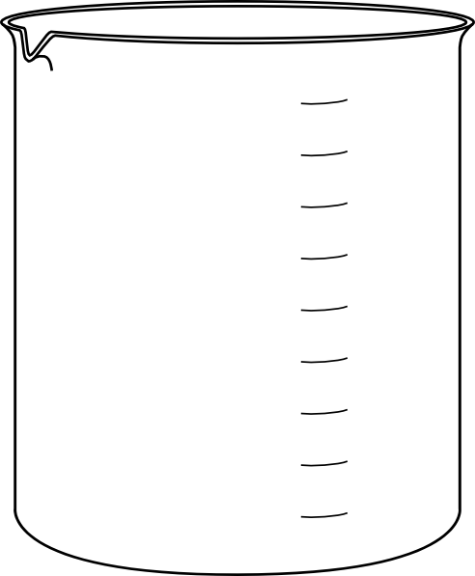  GAS  In gas phase draw a half dozen molecules of the only substance in HCl(g) |  | AQUEOUS  In gas phase draw three particles of all three substances present in HCl(aq)

- Write a balanced equation that shows HClO₄, losing a H+ to form its conjugate base.

- Write a balanced equation that shows HNO₃,losing a H+ to form its conjugate base.

- What happens to hydroxide concentration in water when base is added?
( it rises / it falls / it doesn’t change )

- What happens to the hydronium concentration in water when base is added?
( it rises / it falls / it doesn’t change )

- The following substances act as Bronsted acids in water. Write a chemical equation for each that illustrates its reaction with water.
ammonium ion, NH₄+ | ________________________ ____________________
H₃PO₄ | ________________________ ____________________
HBr | ________________________ ____________________

- The following substances act as Bronsted bases in water. Write a chemical equation for each that illustrates its reaction with water.
CHOO– | ________________________ ____________________
hydride ion: H- | ________________________ ____________________
ammonia NH₃ | ________________________ ____________________

- What is the conjugate acid of HSO4- ?

- What is the conjugate base of HSO4-?

Identify the acid, base, conjugate acid and conjugate base for each of the following.

- HSO₃–(aq) + H₂O(l) ⇄ H₃O⁺(aq) + SO₃^{2–}(aq)

- NH₃(g) + H₂O(l) ⇄ NH₄⁺(aq) + OH–(aq)

- HF(aq) + HSO₃–(aq) ⇄ F–(aq) + H₂SO₃(aq)

- HNO₂(aq) + HS–(aq) ⇄ NO₂–(aq) + H₂S(aq)

- What is the formula for the conjugate acid of water?

- What is the formula for the conjugate base of water?

Atomic Radius Trends.

- In each pair, circle the element that has a greater radius.
- Neon or Helium
- Hydrogen or Helium
- Magnesium or Potassium
- Write a balanced equation for neutral fluorine atom gaining one electron:

____ + ____ ____

- Write a balanced equation for S²⁻ anion losing two electrons:

____ ____ + ____

Electronegativity Trends.
- In each pair, circle the element that has a greater electronegativity.
- phosphorous or chlorine
- phosphorous or antimony
- fluorine or iodine

IONIZATION ENERGY (kJ per mole) |  | - One this graph, next to all twenty dots write words similar to CLOSE or FAR or OTHER WORDS to describe where you think the electron is compared to the nucleus.  - Write the number-number-number style of electron orbits for this atom based on the graph shown here.

- Draw a stable Lewis Dot structure for each molecule:
H₂S | N₂

- Draw a stable Lewis Dot structure for each molecule:
HCl | F₂

- for a NEUTRAL atom with the following electron configuration:
1s²2s²2p⁶3s²3p⁶4s²3d¹⁰5s²4d¹⁰5p¹

Write a ‘number-number-number’ diagram for this atom | Write a Lewis dot diagram (Letter and dots) for this atom | This atom has ________ valence e-  therefore it is (stable / unstable )

- Use your shape table to write the name of the geometric shape based on each molecule’s central atom. Assume each line is a connection between two atoms.
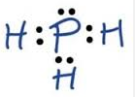 | 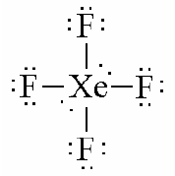 | 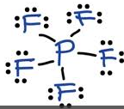 | 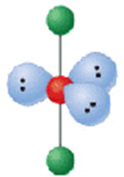
___________________ | ___________________ | ___________________ | ___________________

- Fill in the missing numbers for these two test tube:

Test Tube | OH- concentration | H+ concentration | pH
A |  |  | 2.50
B | 8.04 x 10⁻⁵ M

