Review #2  CλeMis+ry: http://genest.weebly.com  Review #1 was the Camouflage Sheet | 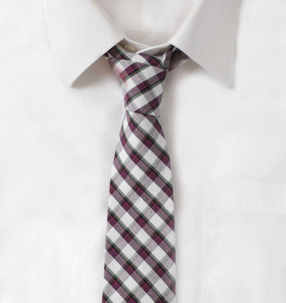 | Name_________  Period________

- For an atom with atomic number =9, charge of zero, and 10 neutrons…
  - mass number _______
  - number of protons? ______
  - number of electrons ______
  - symbol of the element, with highLow numbers ______

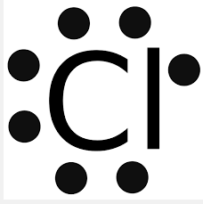 | - For this atom,  - how many total electrons ?  - how many protons?  - how many valence electrons?

- Which of the following elements has the greatest ionization energy?
a. Lithium
b. Calcium
c. Neon
d. Silicon

- What is the high-low symbol of a neutral atom that has a mass of 44 and has 24 neutrons?

- What is the charge of an atom with p = 5, n = 5, e = 8?

- for a NEUTRAL atom with the following electron configuration:
1s²2s²2p⁶3s²3p⁶

Write a ‘number-number-number’ diagram for this atom | Write a Lewis dot diagram (Letter and dots) for this atom | This atom has ________ valence e-  therefore it is (stable / unstable )

- For an atom with 14 protons and 15 neutrons and 18 electrons

  - mass number ______
  - atomic number ______
  - number of electrons ______
  - symbol of the element ______
  - charge of the atom ______
  - symbol of the element, with highLow numbers ______

How many valence electrons are in each of the following?
1s²2s²2p⁵ | a neutral atom of phosphorous | 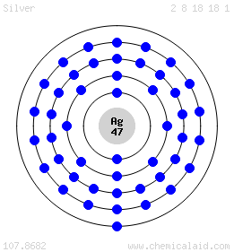 | 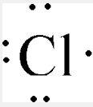
_________ | __________ | __________ | __________

- Choose one of the three choices. “ In neutral atoms…”
  - # of e > # of p
  - # of e = # of p
  - # of e < # of p

- The Law of Conservation of Charge can help us spot wrongly written equations for ions.
  - Ba + 2e- Ba²⁺ possible / impossible
  - F F+ + e- possible / impossible
  - S S²⁺ + 2e- possible / impossible
  - I I⁺ + e- possible / impossible
  - Ag + e- Ag⁺ possible / impossible

- When we speak of ion radius, we speak of their most common ions.
- The ions for metals are usually ( negative / postitive ). The common ions for nonmetals are ( negative / postitive ).

- When metals form cations, the ion is ( smaller / larger ) than the neutral version of the same atom.

- When nonmetals form anions, the ion is ( smaller / larger ) than the neutral version of the same atom.

- Give the formula of the conjugate acid of each: NO₃⁻, H₂O, HSO₄⁻

- Draw a stable Lewis Dot structure for each molecule:
I₂ | OF₂
CO₂ | NI₃

- for a NEUTRAL atom with the following electron configuration:
1s²2s²2p⁶3s²3p⁶4s²3d¹⁰

Write a ‘number-number-number’ diagram for this atom | Write a Lewis dot diagram (Letter and dots) for this atom | This atom has ________ valence e-  therefore it is (stable / unstable )

Write Acid or Base under every substance in each of the following.
- HClO_{4(aq)} + H₂O_{(l)} ⇄ H₃O⁺_{(aq)} + ClO₄–_{(aq)}

- NH_{3(aq)} + H₂O_{(l)} ⇄ OH⁻_{aq)} + NH₄⁺_{(aq)}

- Give the conjugate base of each: HCl, HBr, HI,
- What is the conjugate acid of H₂O ?

- What is the conjugate base of H₃O⁺?
- What is the conjugate acid of OH⁻?
- Write ACID or BASE for each of the following solutions:
  - ___________ litmus paper turns blue
  - ___________the solution feels slippery
  - ___________the pH = 6
  - ___________the pH = 0
  - ___________the solution conducts electricity but does not react with metal
  - ___________the solution has [OH-] < [H+]
  - ___________bromothymol blue is blue (use the table)
  - ___________methyl orange is red
  - ___________[H+] = 0.000999
  - ___________[OH-] = 4.4x10-8
  - ___________when mixed with base water and salt usually form

The Law of Conservation of Charge can help us spot wrongly written equations for ions. circle one answer in each of these reactions:
- Ba + 2e- Ba²⁺ possible / impossible
- F F+ + e- possible / impossible
- S S²⁺ + 2e- possible / impossible
In reversible reactions there is sometimes a conjugated pair of acids and bases.  In the two problems below, connect the conjugate pairs by drawing lines. Identify all four substances in each reaction as either ACID or BASE | 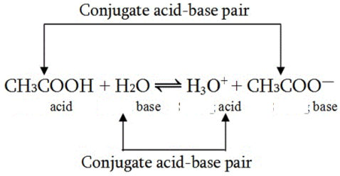
- F–(aq) + H₂SO₃(aq) ⇄ HF(aq) + HSO₃–(aq)

- HNO₂(aq) + HS–(aq) ⇄ NO₂–(aq) + H₂S (aq)

- Write a balanced equation for neutral hydrogen atom gaining one electron:

____ + ____ ____

- The pH scale looks like this (draw it like a number line, including the neutral point and where dangerous acids and dangerous bases start—see your notes from Tuesday):

- Water is right in the middle of being Acid or Base so the pH of pure water has a pH of about _______________
 | Acids | Bases
Turns phenolphthalein what color?
pH | Acids have pH LESS than ___________ | Bases have pH GREATER than _________
Taste (if it’s food)

