acid math  CλeMis+ry: http://genest.weebly.com  Stop in for help every day at lunch and Tues, &Thurs after school!  After-hours question? Email me at home: eagenest@madison.k12.wi.us | D | Name_________  Period________

pH | pOH | [H+] | [OH-]
 | -3 $⍟$ | $$⍟ 4x10-11$$

Complete and balance each reaction
NOTE: all of the acidic H’s will react. If a molecule has H2SO4, both of the H’s will react, for example.
- Mg + HBr Check a box first: This reaction is □metal with acid □ base with acid
_________ + _________ _________ + __________
- Ca(OH)2 + HBr Check a box first: This reaction is □metal with acid □ base with acid
_________ + _________ _________ + __________

- Na + HNO3 Check a box first: This reaction is □metal with acid □ base with acid
_________ + _________ _________ + __________

- NaOH + H2SO4 Check a box first: This reaction is □metal with acid □ base with acid
_________ + _________ _________ + __________

- Ca + H3PO4 Check a box first: This reaction is □metal with acid □ base with acid
_________ + _________ _________ + __________

- LiOH + H3PO4 Check a box first: This reaction is □metal with acid □ base with acid
_________ + _________ _________ + __________

Write the full name of each compound shown below
- Ag₂S  - PbO₃  - Pb₂O₃ | - Zn₃(PO₄)₂  - ZnCO₃  - Fe₂O₃
Write the formula of each compound shown below
- sodium phosphate  - copper (II) nitrate  - copper (II) nitride | - magnesium nitrite  - tin(IV) oxide  - Aluminum Iodide
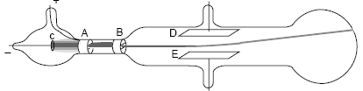
- What did JJ Thomson conclude was shooting in a line from left to right in this drawing? (circle one choice)

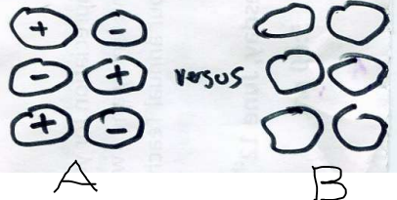
Mark yes or no for each statement below about the particles of matter shown here

- _________ If dissolved in water, Substance B would probably conduct electricity
- _________ Substance B will melt at a lower temperature than Substance A
- _________ The one most likely to be a molecular substance is Substance A

- When you ripped the tapes apart in the Sticky Tape Lab, the two pieces of tape were then attracted to each other. An hypothesis was proposed to account for this observation. Which of the following features of the hypothesis is NOT supported by this observation alone?
a. Some charged particle was transferred between atoms of the two tapes.
b. Atoms contain smaller particles that carry an electric charge.
c. The smaller, charged particle in the atom is negatively charged.
d. The smaller, charged particle in the atom is mobile.

- Which of the following substances would you expect to conduct electricity?
a. bleach (a solution of sodium hypochlorite, NaOCl, in water)
b. dry baking soda (NaHCO₃)
c. rubbing alcohol (C₃H₈O)
d. sugar (C₁₂H₂₂O₁₁) dissolved in water

- Below left is group of neutral atoms of paper. At the right, draw electrons as dots to sketch how you imagine the electrons would be arranged if a (+) tape were placed to the right of the sample of paper. Briefly state your reasoning for your diagram.
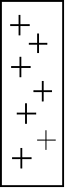

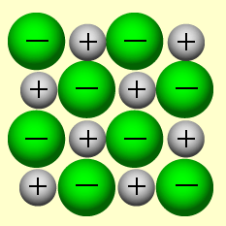
- Circle one choice below. The image here is a good description of a compound made from only
  - sulfur and oxygen
  - potassium and chlorine

- The atoms in a molecular solid are arranged in a nice orderly array similar to the crystal lattice shown in the previous question. However, there are key differences. State two ways in which a molecular substance differs from an ionic substance.
One way: | Another way:

- In (NH4)2CO3
  - What is the total number of cations formed when it dissolves?
  - What is the total number of anions formed when it dissolves?

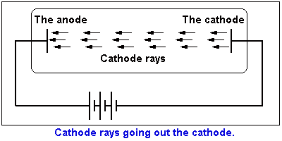
- In Thomson’s Cathode ray tube, electrons flew from the cathode to the anode in the vacuum of a tube similar to this one.
In the space below, draw circular ‘plum pudding’ atoms with black electron dots, similar to those in previous answers, to show, microscopically, what would be happening to the metal atoms in the cathode during this experiment.

