acids tuesday  CλeMis+ry: http://genest.weebly.com  Stop in for help every day at lunch and Tues, &Thurs after school!  After-hours question? Email me at home: eagenest@madison.k12.wi.us | G | Name_________  Period________

acid base problems:
Our memorized Formulas for Acid Base Math:
pH = - log[H+]  pOH = -log[OH-] | 1x10⁻¹⁴ = [H+][OH-]  14 = pH + pOH
- Solve these using your formulas (conveniently printed at the bottom of this page
pH | pOH | [H+] | [OH-]
13.0 | 7.4

- In the reaction below, connect the conjugate pairs with a line. Write “acid” or “base” below each of the four substances.

NH₄⁺ + OH⁻ $⇆$ HOH + NH₃

x
- Next to each, write its conjugate base:

NH₄⁺______ NH₃ ______NH₂- ______H₂O H₃O⁺ ______
- Complete and balance each reaction
NOTE: all of the acidic H’s will react. If a molecule has H₂SO₄, both of the H’s will react, for example.

Al(OH)₃ reacting with HF Check a box first: This reaction is □metal with acid □ base with acid

_________ + _________ _________ + __________

Fe reacting with HNO₃ Hint: one of the products formed is named IRON(iii) NITRATE.
Check a box first: This reaction is □metal with acid □ base with acid

_________ + _________ _________ + __________

Sort of a review of Unit 7 (FEB 13 to MARCH 9)
- What does the Law of Conservation of Mass say must ALWAYS ALWAYS ALWAYS be true about the mass of the Reactants in any reaction in the history of the entire Universe?

- To change each sentence below into a correct chemical reaction you must .
- write the correct formulas for each reactant and product by either making sure each compound has a neutral charge or by using a criss cross technique. (i.e. CaF is incorrect, CaF2 is correct)
- only then should you proceed to wri
a.. When solid potassium chlorate is strongly heated in a flame it forms oxygen gas and solid potassium chloride.

_________ + _________ _________ + __________

b. Zinc and lead (II) nitrate react to form zinc nitrate and lead.

_________ + _________ _________ + __________

4. When 3M HCl is added to solid sodium carbonate, the contents of the test tube immediately starts bubbling and gets warm. Carbon dioxide gas, water vapor and sodium chloride are formed. In the LOL diagram below you should first show chemical energy changing to thermal energy and then in a separate step show heat leaving the system as an arrow. 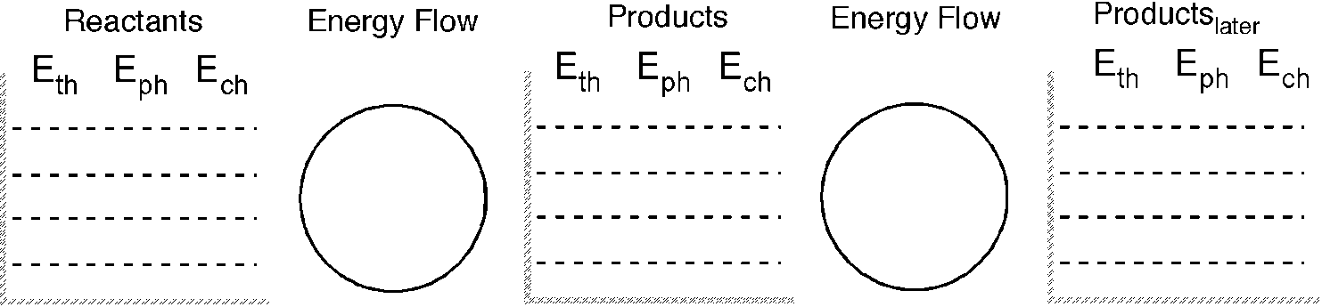
6. What type of reactions are the following?
Matching. Use each choice once. What type of reactions are shown here?
_______ AB + C CB + A  _______ A + B AB  _______ AB A + B  _______ AB + CD CB + AD | - combination (sometimes called synthesis)  - decomposition  - single replacement  - double replacement
- In an endothermic reaction, is the energy of the products less than or greater than that of the reactants?

- Convert each of the following energy units:
  - 8.1 kcal to cal

  - 2.50 kcal to J

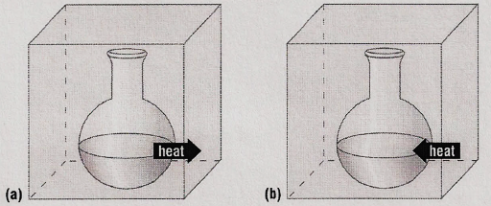
Some substances reacted in two flaskes. For each stzatement below, choose either Reaction A or Reaction B
- ________ For the substances in the reaction E_{ch} is decreasing
- ________ The reaction could be written A + energy B
- ________ The reaction could be written A B ∆H = -500kJ
- ________ The ∆H = + 300 kJ
- ________ The reaction is exothermic
- ________ The reaction would feel cold if you held the flask in your hand.
Energy in Chemical Reactions
- Classify the following as exothermic or endothermic:
- 550 kJ is released
- The energy level of the products is higher than that of the reactants.
- Classify the following as exothermic or endothermic reaction and give ΔH for each:
- Gas burning in a Bunsen burner: CH₄ + 2O₂ → CO₂ + 2H₂O + 890 kJ
- Dehydrating limestone: Ca(OH)₂ + 65.3 kJ → CaO + H₂O
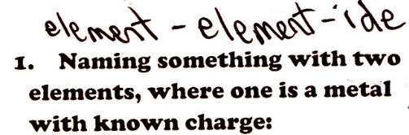
- After each formula write the name.
- Ca₃P₂ ___________  - ZnO ___________  - Na₂S___________ | - Al₂Se___________  - LiH___________  - BeBr₂___________

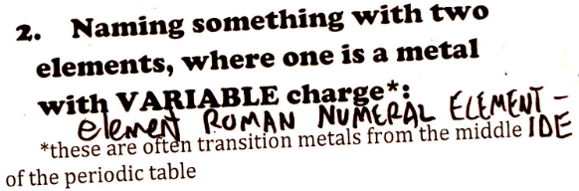
- Just figure out the charge on the metal atom.
- PbO₂  - CoCl₂ | - Au(OH)₂  - Fe₂(CrO₄)₃
- Name each. From your answers above, use the charge of the metal atom and then write a roman numeral
- PbO₂  - CoCl₂ | - Au(OH)₂  - Fe₂(CrO₄)₃
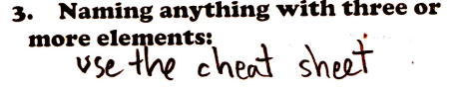
- Name each
- Na₂(CO₃)  - Mg(MnO₄)₂ | - (NH₄)₃PO₄  - Cu(ClO₃)₂*
*remember to find the charge on the metal and give this one a roman numberal.
- Circle any formula that would need a roman numeral when giving this a name.
Na₂(CO₃) FeCO₃ Sn₃(PO₄)₂ (NH₄)NO₃ CaSO₄

